**DevSecOps : Netflix Clone CI-CD with Monitoring | Email**

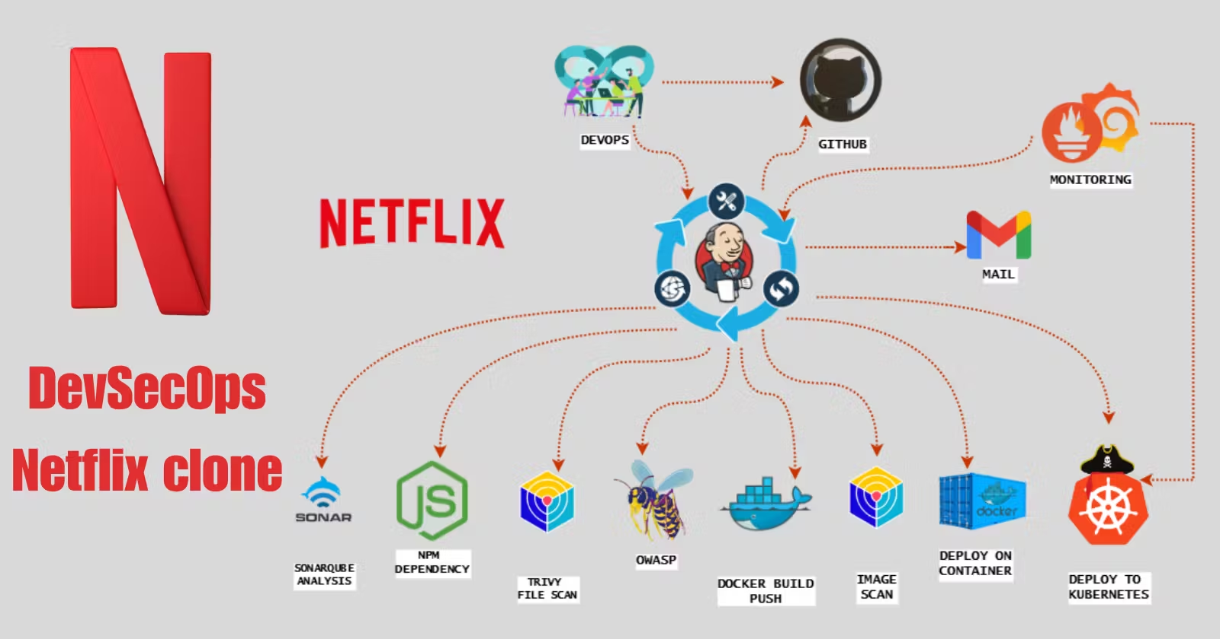

Note: We will be deploying a Netflix clone. We will be using Jenkins as a CICD tool and deploying our application on a Docker container and Kubernetes Cluster and we will monitor the Jenkins and Kubernetes metrics using Grafana, Prometheus and Node exporter.

Step 1:

A. Select region North virginia

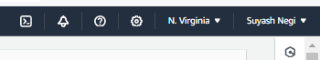

B. launch an instance.

Name: jenkins-sonar:

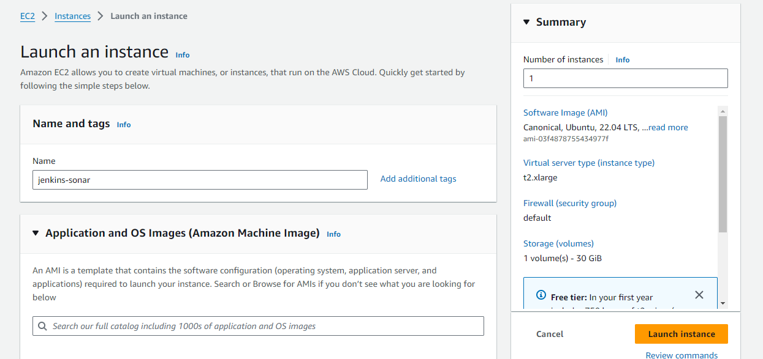

Os: ubuntu.

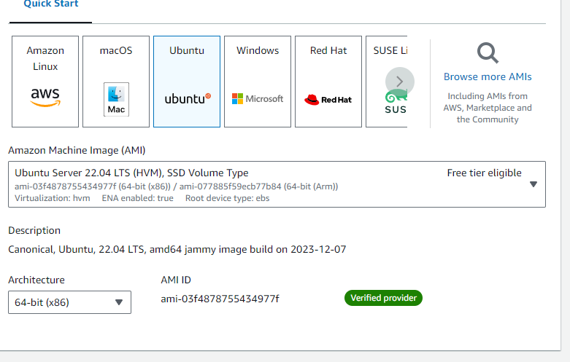

Instance type : t2.xlarge

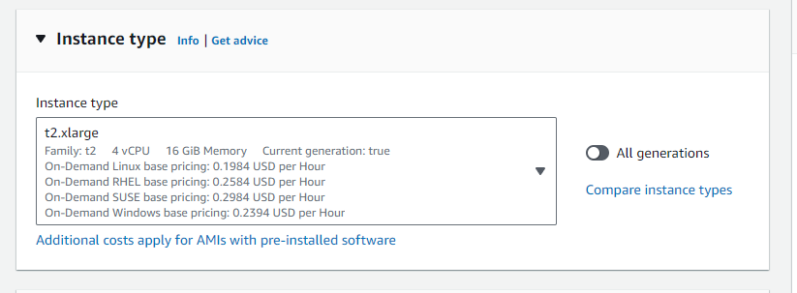

Select a key pair.

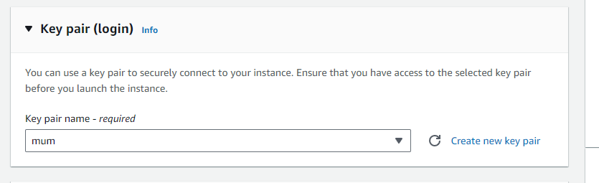

Use default Sg: all traffic allowed. (only for learning purposes).

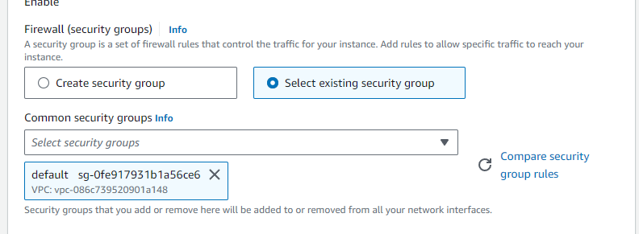

Storage: increase from 8gb to 30gb for file and dependencies.

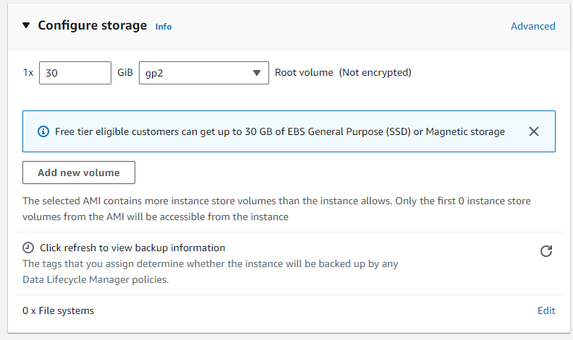

Go to advanced options: user data and paste data after the image in the respective section:

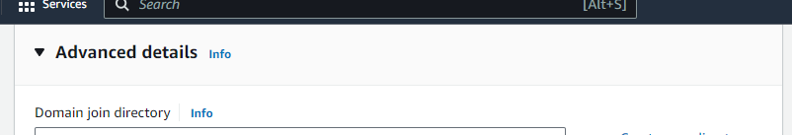

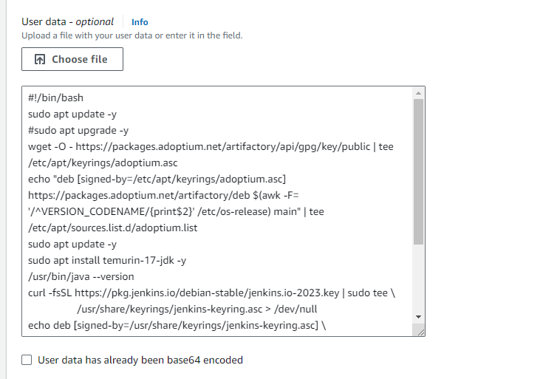

#!/bin/bash

sudo apt update -y

#sudo apt upgrade -y

wget -O - <https://packages.adoptium.net/artifactory/api/gpg/key/public> | tee /etc/apt/keyrings/adoptium.asc

echo "deb [signed-by=/etc/apt/keyrings/adoptium.asc] <https://packages.adoptium.net/artifactory/deb> $(awk -F= '/^VERSION_CODENAME/{print$2}' /etc/os-release) main" | tee /etc/apt/sources.list.d/adoptium.list

sudo apt update -y

sudo apt install temurin-17-jdk -y

/usr/bin/java --version

curl -fsSL <https://pkg.jenkins.io/debian-stable/jenkins.io-2023.key> | sudo tee \

/usr/share/keyrings/jenkins-keyring.asc > /dev/null

echo deb [signed-by=/usr/share/keyrings/jenkins-keyring.asc] \

[https://pkg.jenkins.io/debian-stable binary/](https://pkg.jenkins.io/debian-stable%20binary/) | sudo tee \

/etc/apt/sources.list.d/jenkins.list > /dev/null

sudo apt-get update -y

sudo apt-get install jenkins -y

sudo systemctl start jenkins

sudo systemctl status jenkins

-------------------------------------------------------------------------------------------------------------------

Lastly, Launch the instance.

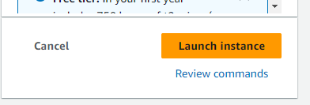

========================================================================

Step 2:

Launch Another instance which will have grafana and prometheus.



A. Name the instance:

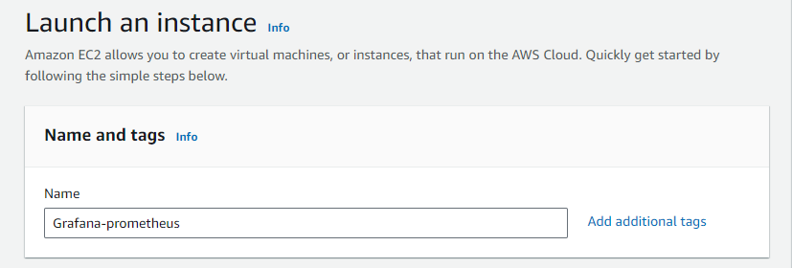

B. Use Ubuntu as base image: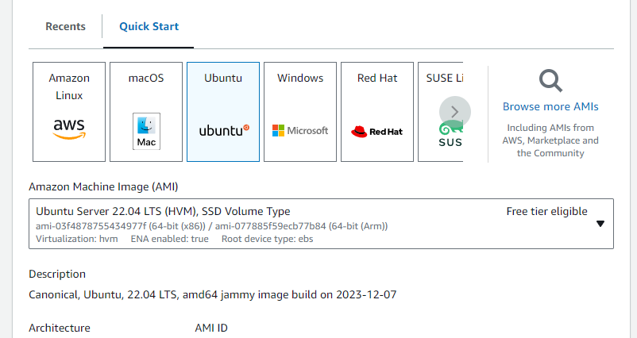

C. Select t2.medium as instance type: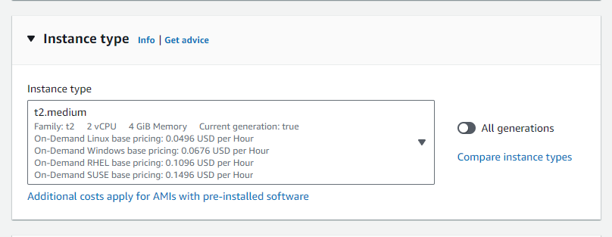

D. Select the key pair:

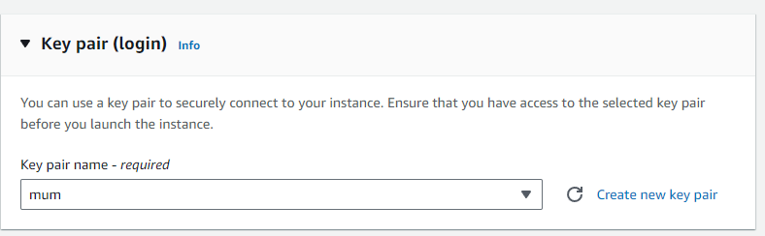

E. You also can use Default SG as it has all traffic allowed already: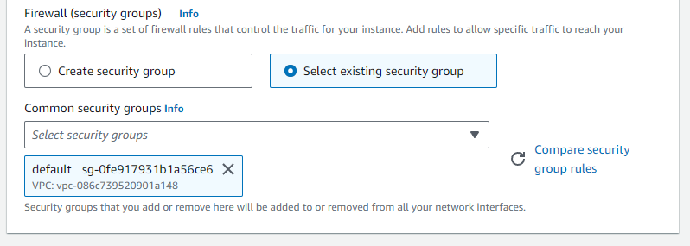

F. Increase storage upto 12gb.

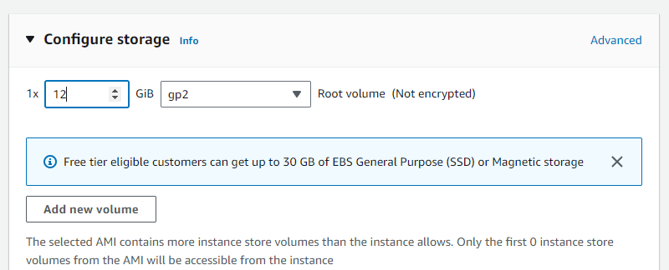

G. Finally launch the instance:

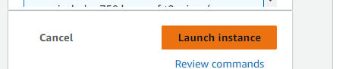

========================================================================Step 3: connect to jenkins-sonar server with putty and check the status jenkins:

ubuntu@ip-172-31-93-14:~$ sudo systemctl status jenkins

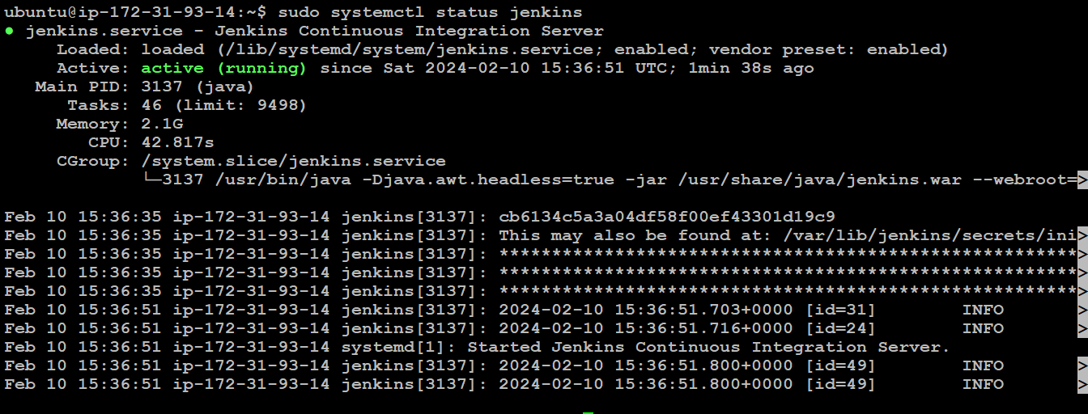

A. Switch to root user and check the default password for jenkins login in this path file:

root@ip-172-31-93-14:/home/ubuntu# cd /var/lib/jenkins/secrets/

cat initialAdminPassword ------------------ copy the password from it.

B. Open a new tab in browser: ip add of your instance:8080

C. Enter the copied password here:

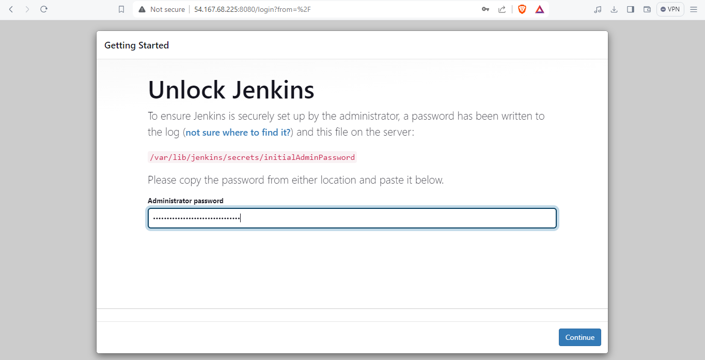

D. Click Install suggested plugins.

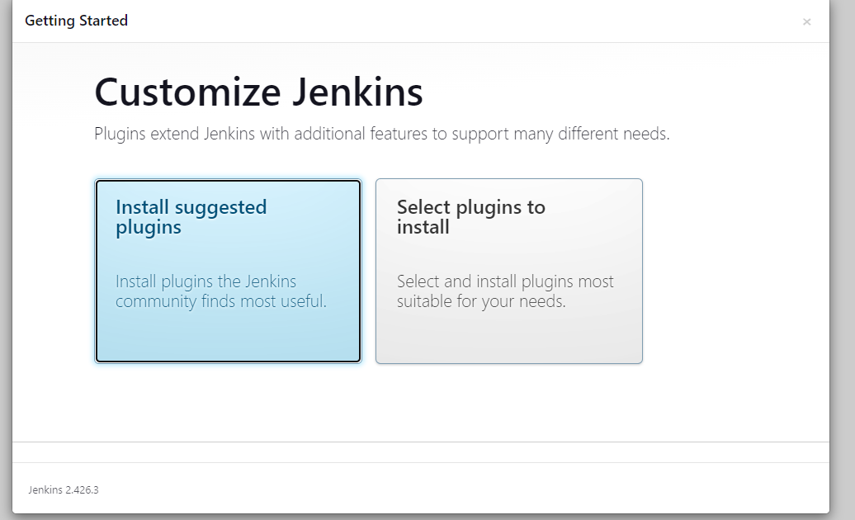

E. Wait here for few seconds:

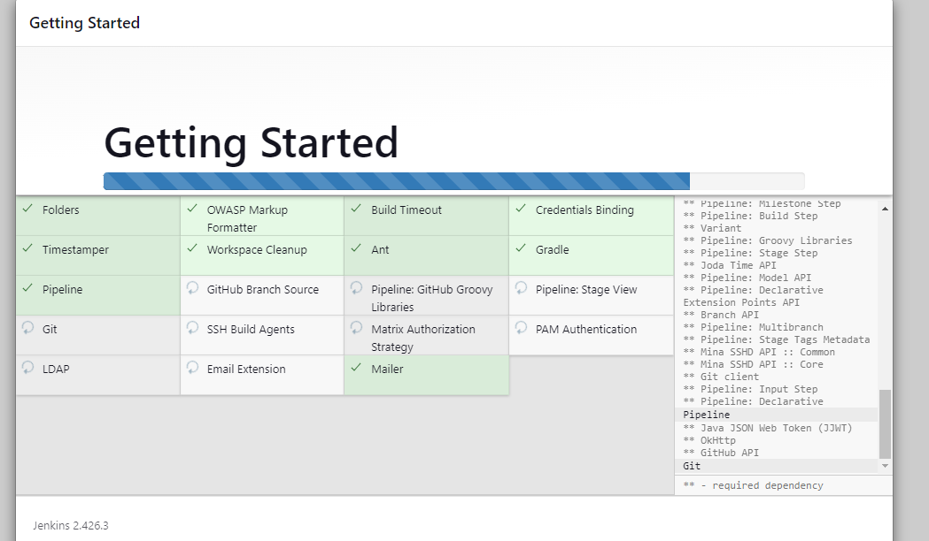

F. Setup up user and its password

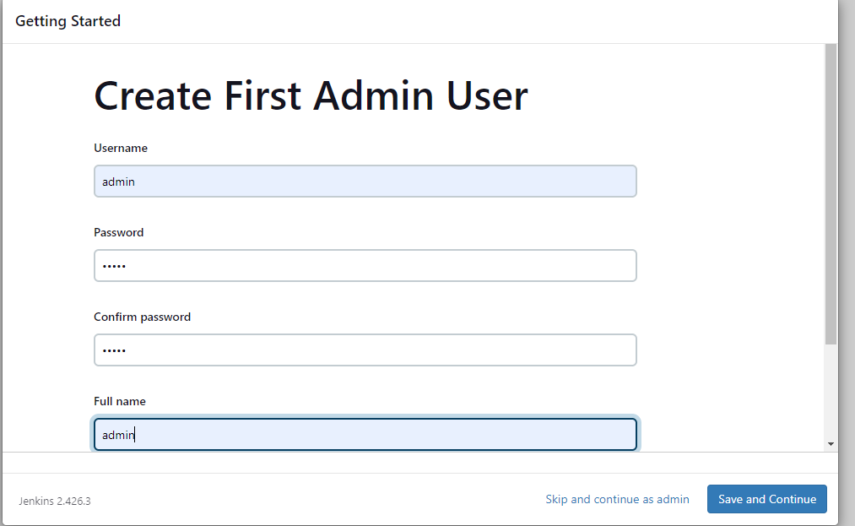

G. Click on save and continue:

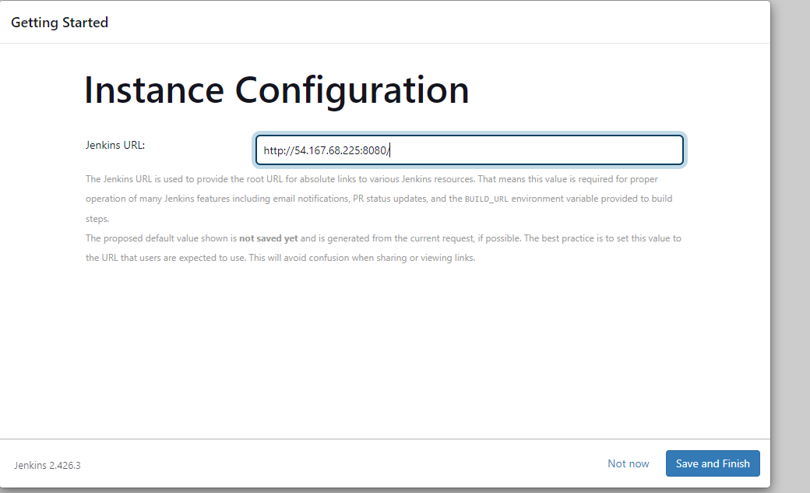

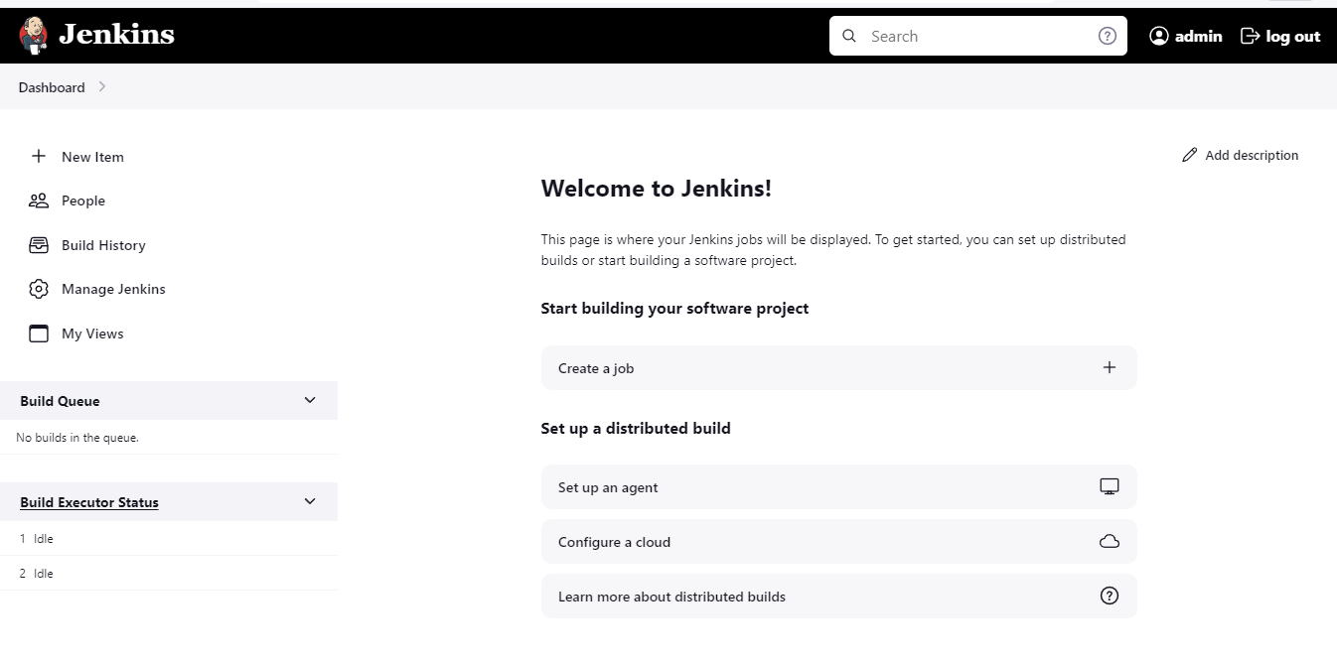

H. Go to your Jenkins-sonar instance and install docker with this cmd:

* sudo apt-get update -y
* sudo apt-get install docker.io -y
* sudo usermod -aG docker ubuntu
* newgrp docker--refresh the group
* sudo chmod 777 /var/run/docker.sock --- to avoid error while running the pipeline.

Now do docker ps ----It must not show any error:

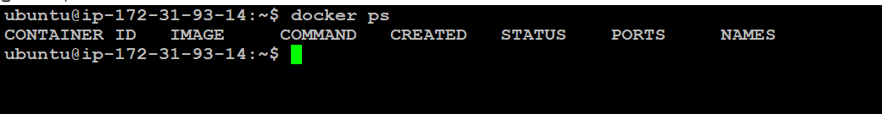

I. Now run the sonarqube as a Docker-container:

Command: docker run -d --name sonar -p 9000:9000 sonarqube:lts-community

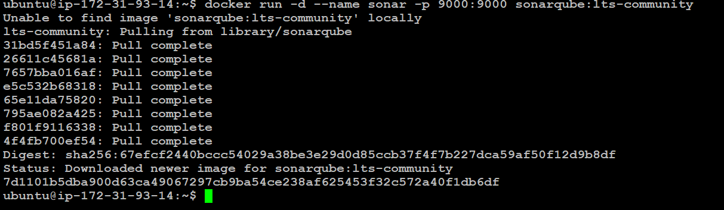

Connect with SonarQube --- ip add:9000:

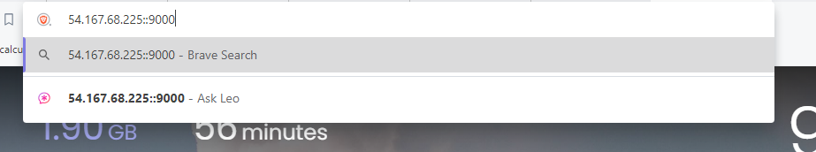

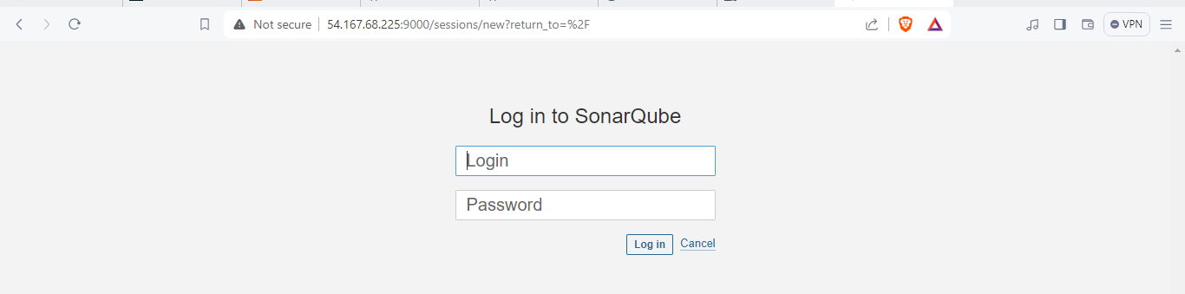

User: admin

password: admin

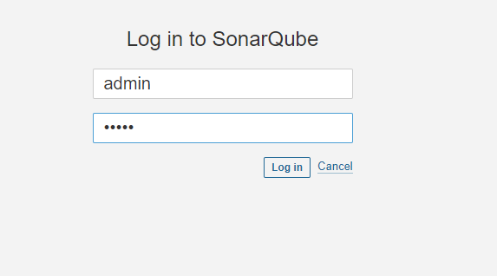

J. Update the password of sonar

admin1

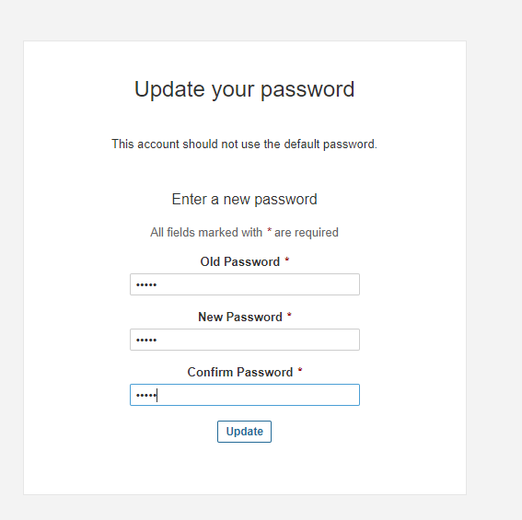

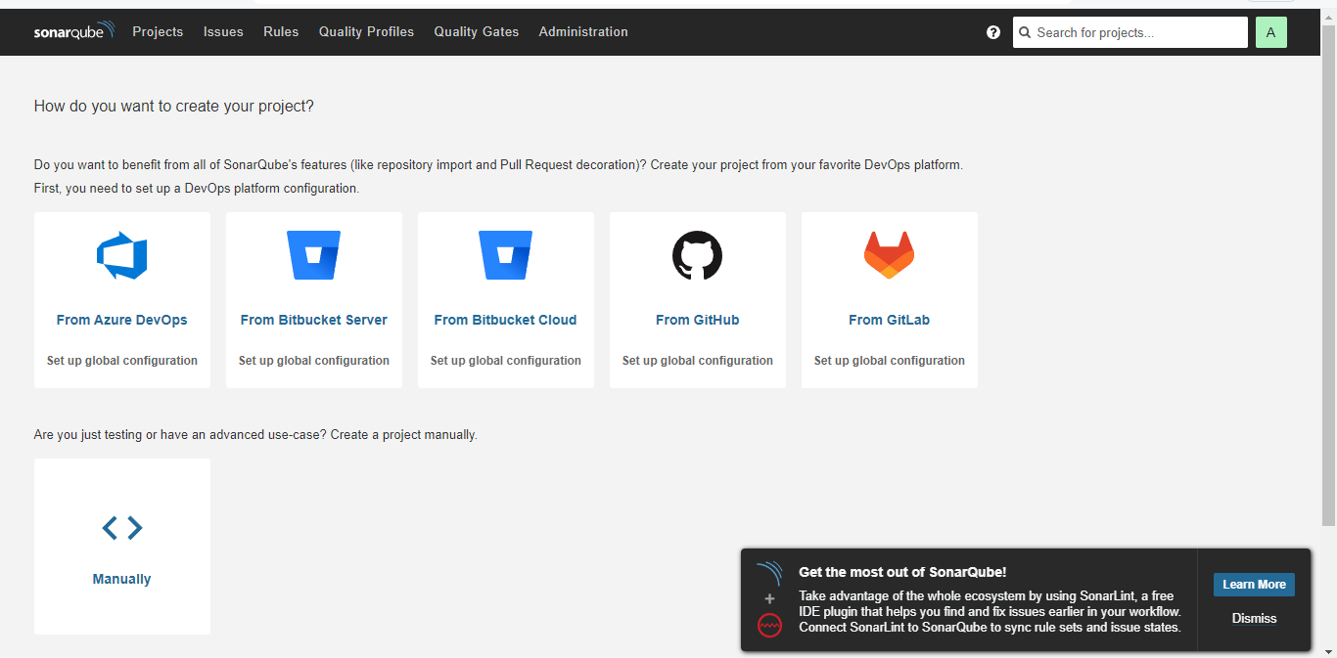

Step 4.

A. Install Trivy --- to scan every file from our repo and scan the docker image also we are installing trivy on our jenkins-sonar instance.

vi trivy.sh-----create a script and run it with 777

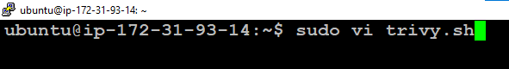

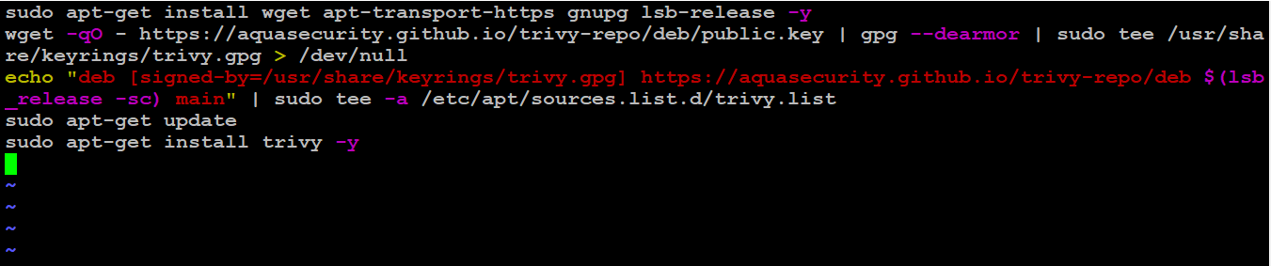

* sudo apt-get install wget apt-transport-https gnupg lsb-release -y
* wget -qO - <https://aquasecurity.github.io/trivy-repo/deb/public.key> | gpg --dearmor | sudo tee /usr/share/keyrings/trivy.gpg > /dev/null
* echo "deb [signed-by=/usr/share/keyrings/trivy.gpg] <https://aquasecurity.github.io/trivy-repo/deb> $(lsb_release -sc) main" | sudo tee -a /etc/apt/sources.list.d/trivy.list
* sudo apt-get update
* sudo apt-get install trivy -y

Key reference:

* ubuntu@ip-172-31-93-14:~$
* ubuntu@ip-172-31-93-14:~$ sudo vi trivy.sh
* ubuntu@ip-172-31-93-14:~$ sudo vi trivy.sh
* ubuntu@ip-172-31-93-14:~$ sudo chmod +x trivy.sh
* ubuntu@ip-172-31-93-14:~$ ls -ltr

total 4

* -rwxr-xr-x 1 root root 427 Feb 10 16:24 trivy.sh
* ubuntu@ip-172-31-93-14:~$ sh trivy.sh

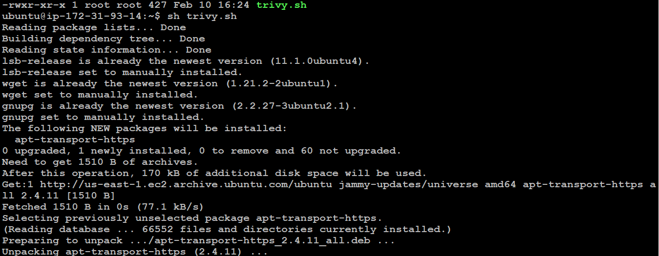

========================================================================

Step 5.

A. Create a TMDB API Key. Next, we will create a TMDB API key. Open a new tab in the Browser and search for TMDB.

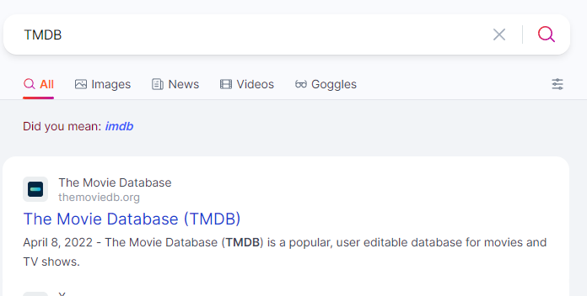

B. Click on login and create an account:



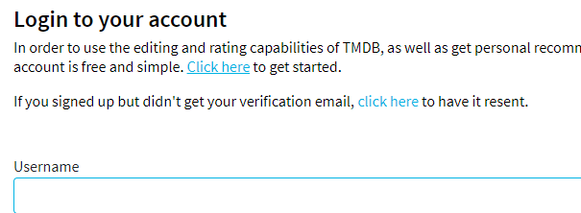

Like this:

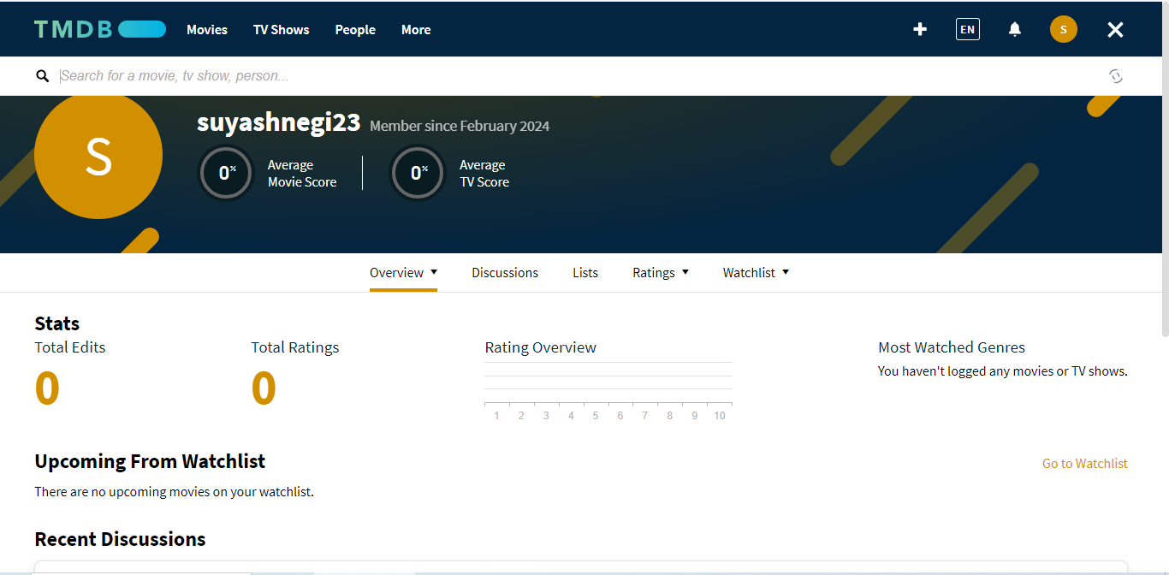

C. Go to settings

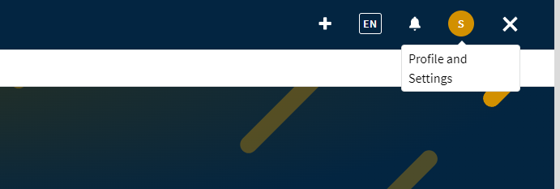

Click on api and copy your api key.

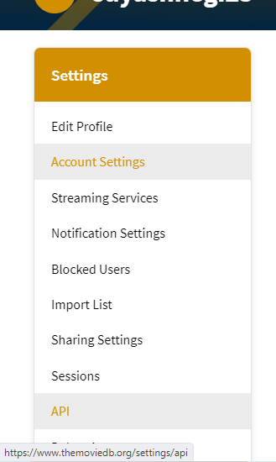

Now click on create

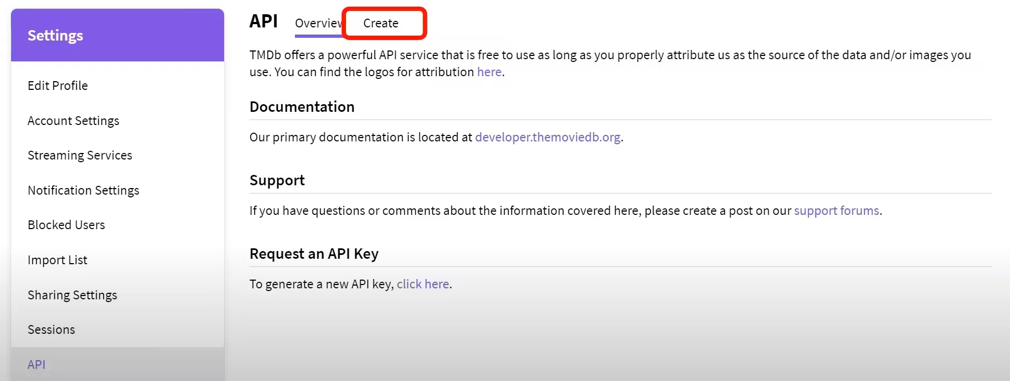

Click on Developer

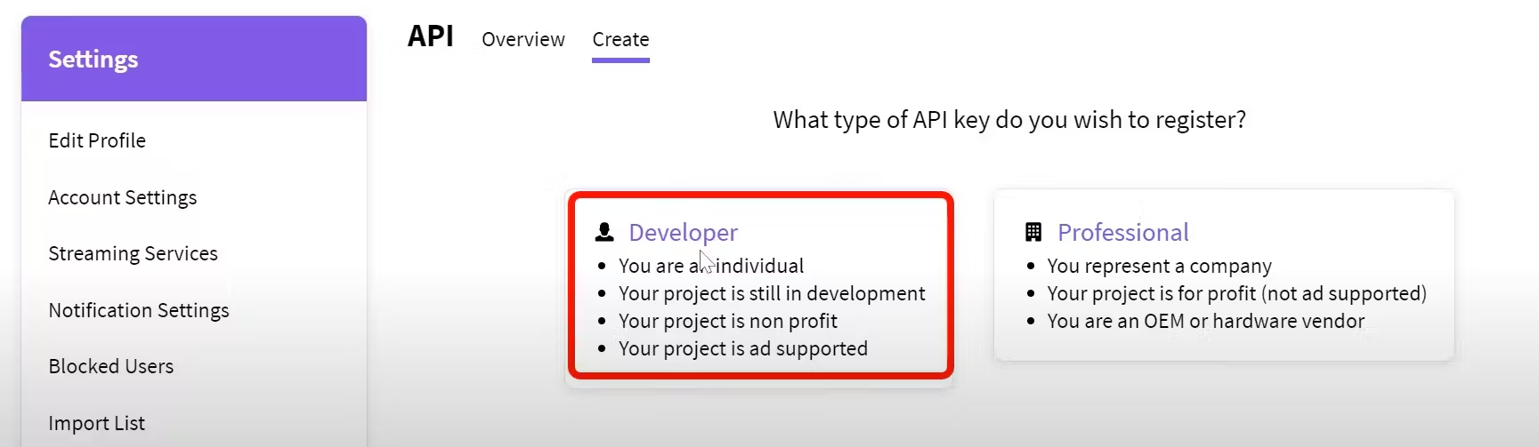

Now you have to accept the terms and conditions.

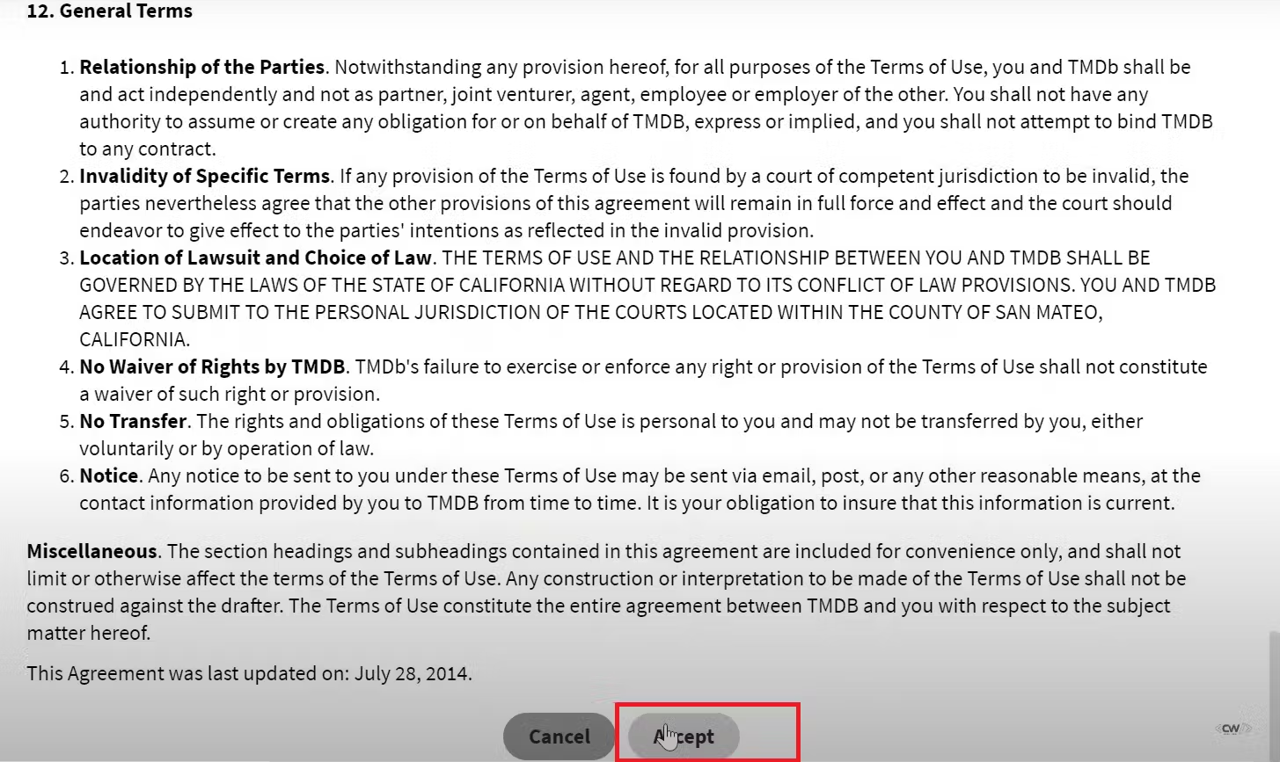

Provide basic details:

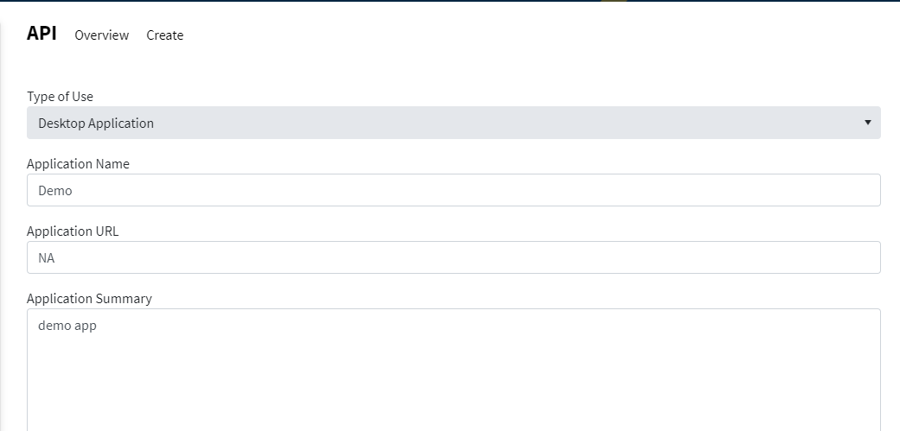

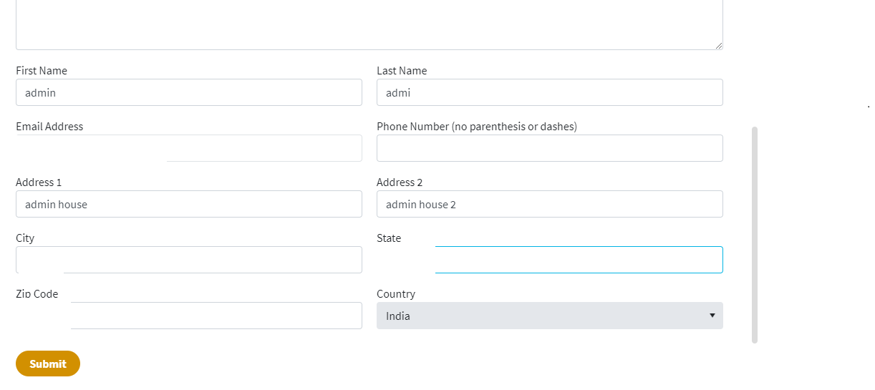

Click on submit and copy the api key:

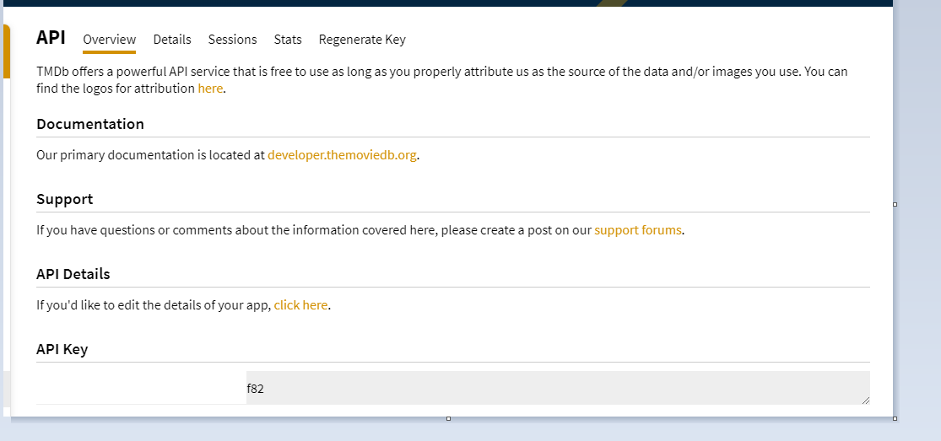

Step 6:

A. Install Prometheus and Grafana On the new Server, Connect with your secondary instance with t2.medium configs run these cmds:

* sudo useradd \

--system \

--no-create-home \

--shell /bin/false prometheus

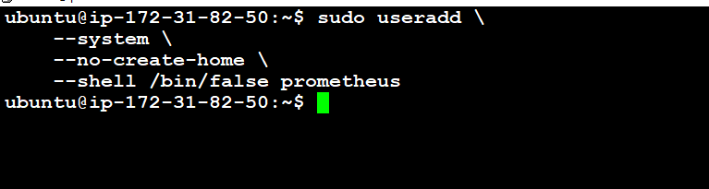

B. You can use the curl or wget command to download Prometheus:

* wget <https://github.com/prometheus/prometheus/releases/download/v2.47.1/prometheus-2.47.1.linux-amd64.tar.gz>

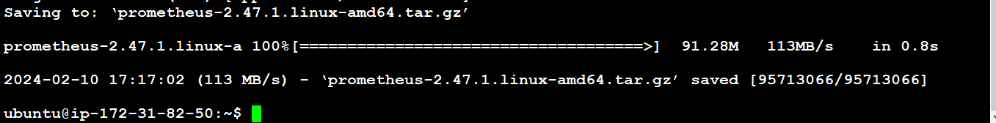



C. Now extract the tar file : tar -xvf prometheus-2.47.1.linux-amd64.tar.gz

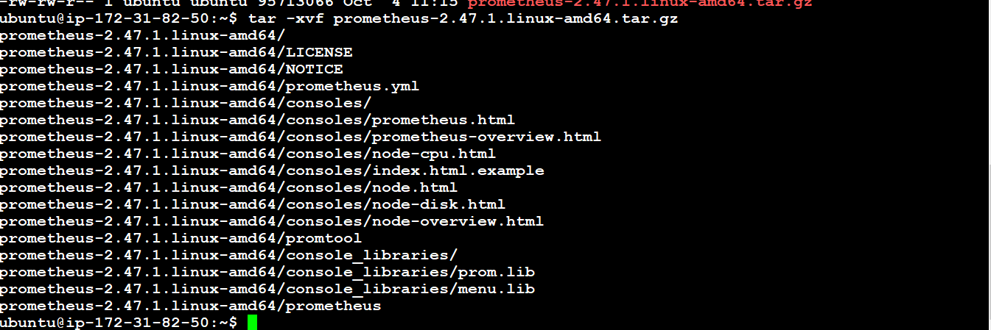

D.Usually, you would have a disk mounted to the data directory. For this tutorial, I will simply create a /data directory. Also, you need a folder for Prometheus configuration files.

* sudo mkdir -p /data /etc/prometheus
* cd prometheus-2.47.1.linux-amd64/ ------Now, let's change the directory to Prometheus and move some files.
* ls -l ---long listing
* sudo mv prometheus promtool /usr/local/bin/ ------First of all, let's move the Prometheus binary and a promtool to the /usr/local/bin/. promtool is used to check configuration files and Prometheus rules.
* sudo mv consoles/ console_libraries/ /etc/prometheus/ ------------- Optionally, we can move console libraries to the Prometheus configuration directory. Console templates allow for the creation of arbitrary consoles using the Go templating language. You don't need to worry about it if you're just getting started.
* sudo mv prometheus.yml /etc/prometheus/prometheus.yml ----- Finally, let's move the example of the main Prometheus configuration file.
* sudo chown -R prometheus:prometheus /etc/prometheus/ /data/ ------To avoid permission issues, you need to set the correct ownership for the /etc/prometheus/ and data directory.
* cd
* rm -rf prometheus-2.47.1.linux-amd64.tar.gz ---------------------You can delete the archive and a Prometheus folder when you are done.



**Verify that you can execute the Prometheus binary by running the following command:**

ubuntu@ip-172-31-82-50:~$ prometheus --version

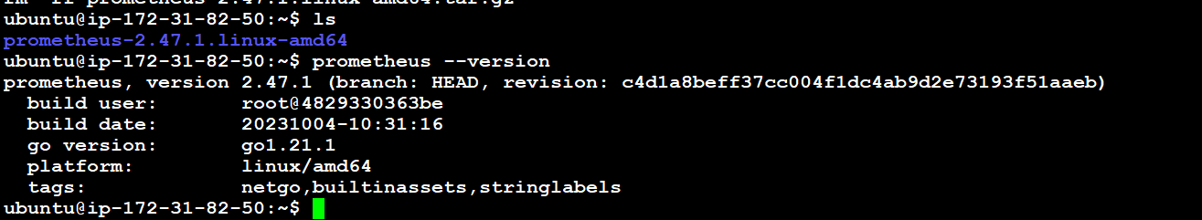

E. We're going to use some of these options in the service definition. We're going to use Systemd, which is a system and service manager for Linux operating systems. For that, we need to create a Systemd unit configuration file.

* sudo vim /etc/systemd/system/prometheus.service



**And insert this:**

[Unit]

Description=Prometheus

Wants=network-online.target

After=network-online.target

StartLimitIntervalSec=500

StartLimitBurst=5

[Service]

User=prometheus

Group=prometheus

Type=simple

Restart=on-failure

RestartSec=5s

ExecStart=/usr/local/bin/prometheus \

--config.file=/etc/prometheus/prometheus.yml \

--storage.tsdb.path=/data \

--web.console.templates=/etc/prometheus/consoles \

--web.console.libraries=/etc/prometheus/console_libraries \

--web.listen-address=0.0.0.0:9090 \

--web.enable-lifecycle

[Install]

WantedBy=multi-user.target

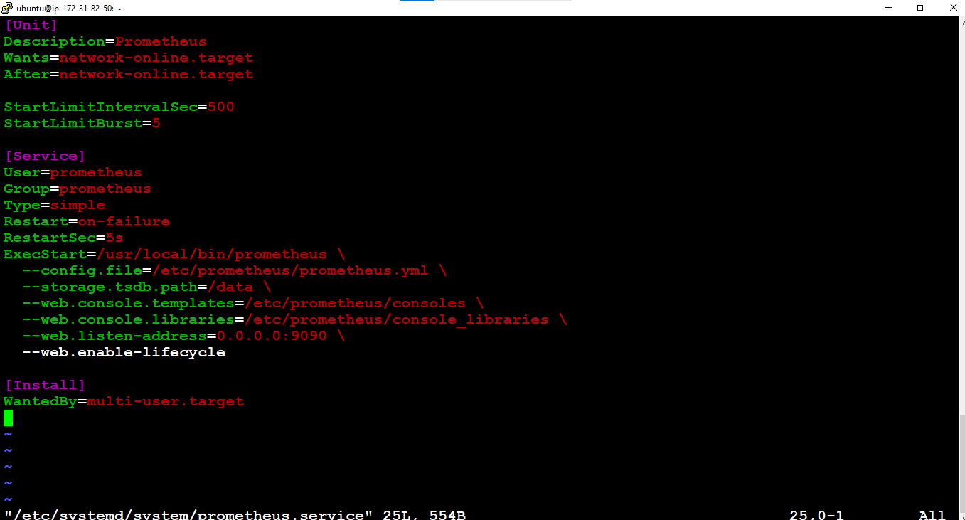

* sudo systemctl enable prometheus
* sudo systemctl start prometheus
* sudo systemctl status prometheus

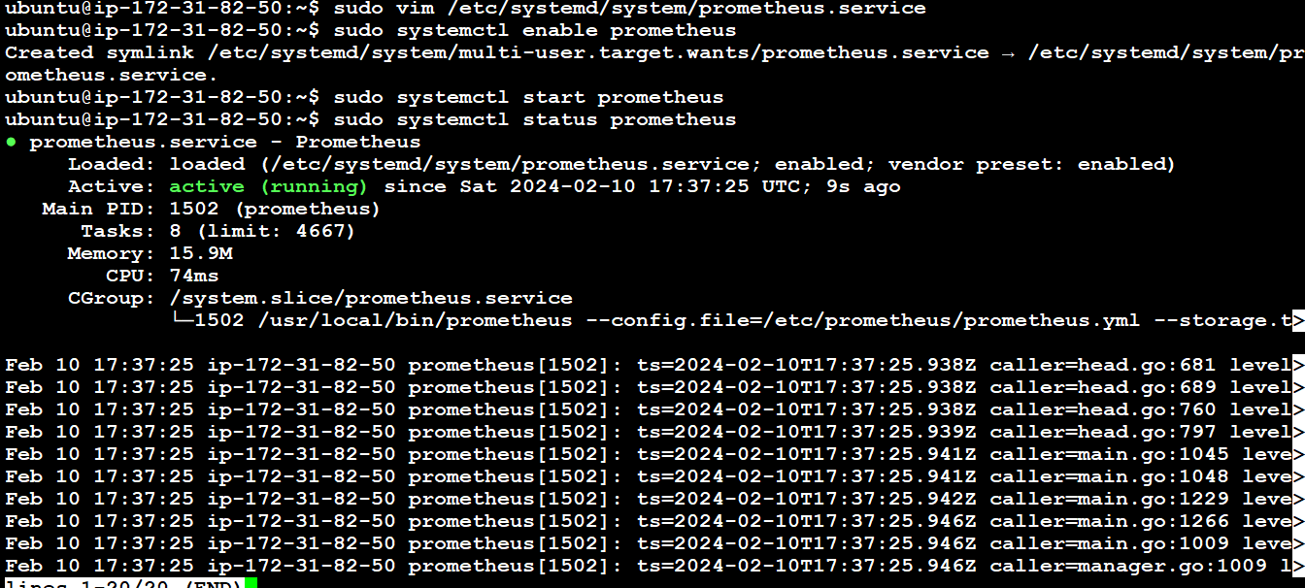

F. Suppose you encounter any issues with Prometheus or are unable to start it. The easiest way to find the problem is to use the journalctl command and search for errors.

* journalctl -u prometheus -f --no-pager

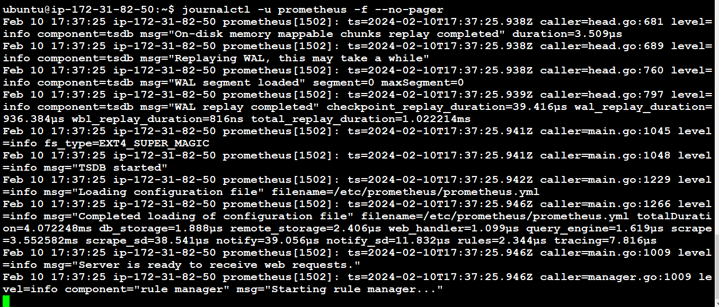

G. Now we can try to access it via the browser. I'm going to be using the IP address of the Ubuntu server. You need to append port 9090 to the IP

* <public-ip:9090>



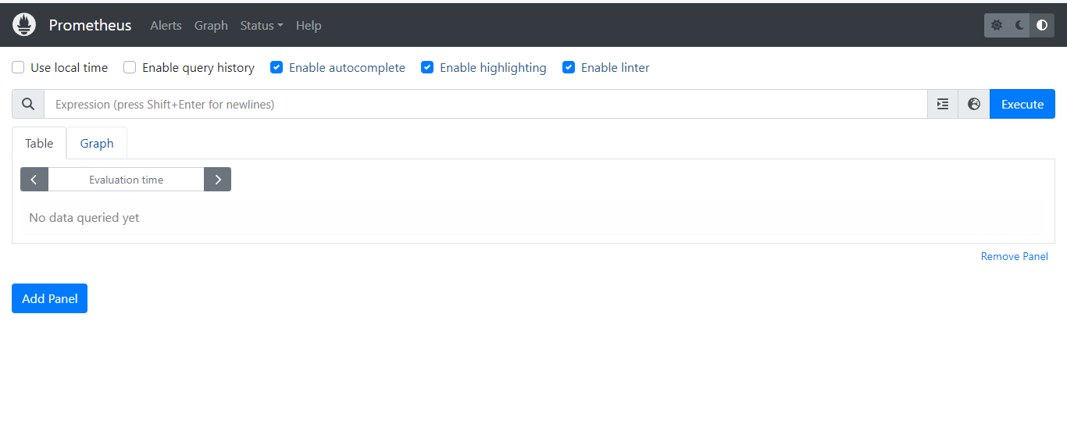

H. **Install Node Exporter on Ubuntu 22.04:** Next, we're going to set up and configure Node Exporter to collect Linux system metrics like CPU load and disk I/O. Node Exporter will expose these as Prometheus-style metrics. Since the installation process is very similar, I'm not going to cover as deep as Prometheus.

-First, let's create a system user for Node Exporter by running the following command:

* sudo useradd \
* --system \
* --no-create-home \
* --shell /bin/false node_exporter

You can download Node Exporter from the same page:

* wget <https://github.com/prometheus/node_exporter/releases/download/v1.6.1/node_exporter-1.6.1.linux-amd64.tar.gz>

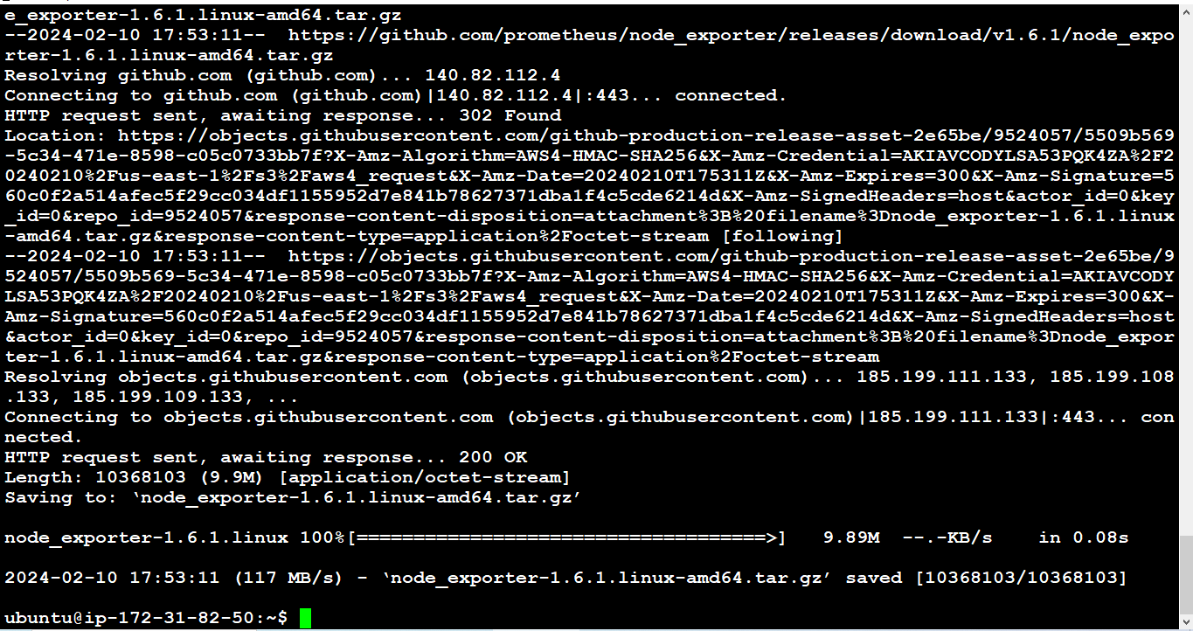

Extract cmd:

* tar -xvf node_exporter-1.6.1.linux-amd64.tar.gz

**Now move dependencies with these cmds:**

sudo mv \

node_exporter-1.6.1.linux-amd64/node_exporter \

/usr/local/bin/

**Verify that you can run the binary.**

* node_exporter --version

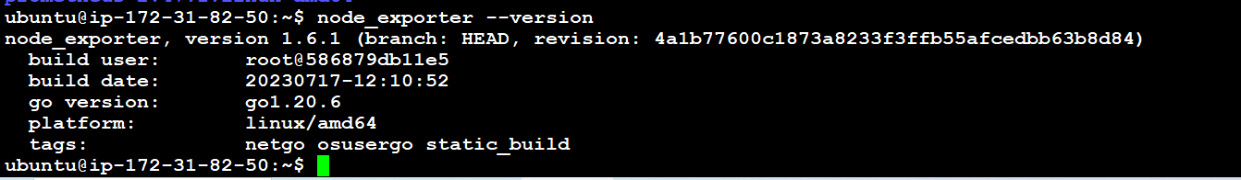

**Next, create a similar systemd unit file.**

* sudo vim /etc/systemd/system/node_exporter.service



**And insert this:**

[Unit]

Description=Node Exporter

Wants=network-online.target

After=network-online.target

StartLimitIntervalSec=500

StartLimitBurst=5

[Service]

User=node_exporter

Group=node_exporter

Type=simple

Restart=on-failure

RestartSec=5s

ExecStart=/usr/local/bin/node_exporter \

--collector.logind

[Install]

WantedBy=multi-user.target

------------------------------------------------------------------------------------------------------------------

Refference:

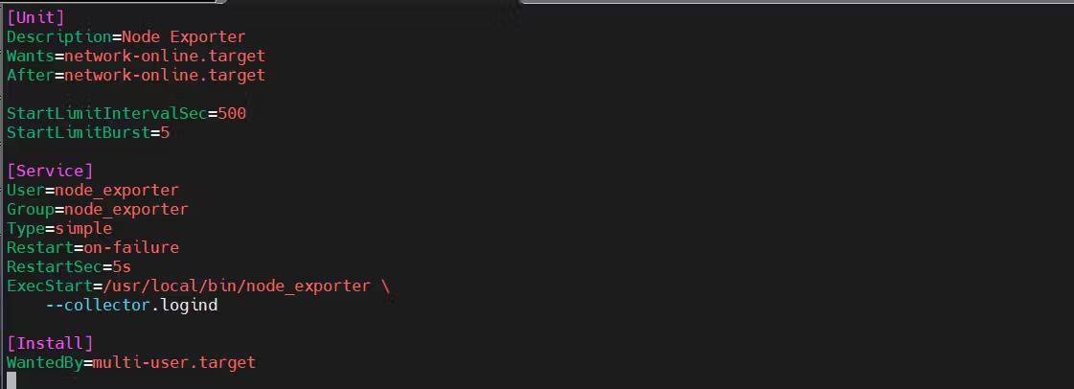

============================================================================

I. **Configure Node exporter for os also:**

* sudo systemctl enable node_exporter
* sudo systemctl start node_exporter
* sudo systemctl status node_exporter
* journalctl -u node_exporter -f --no-pager --------------------onlu if error occurs in previous step.

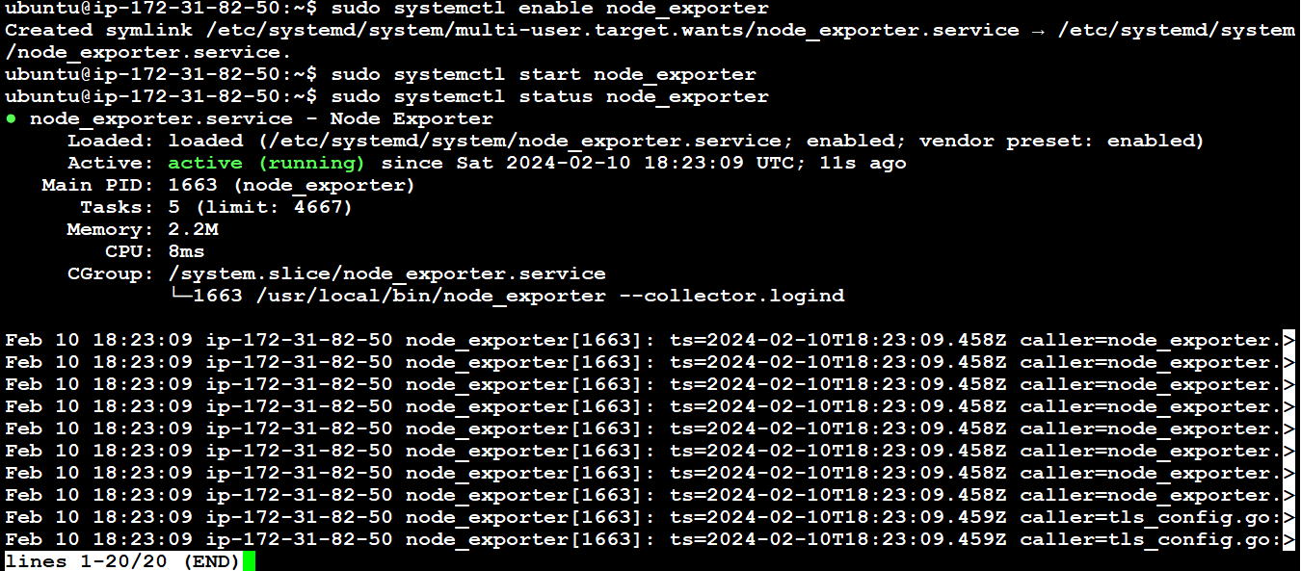

**J.To create a static target, you need to add job_name with static_configs.**

* sudo vim /etc/prometheus/prometheus.yml

Content:

- job_name: node_export

static_configs:

- targets: ["localhost:9100"]

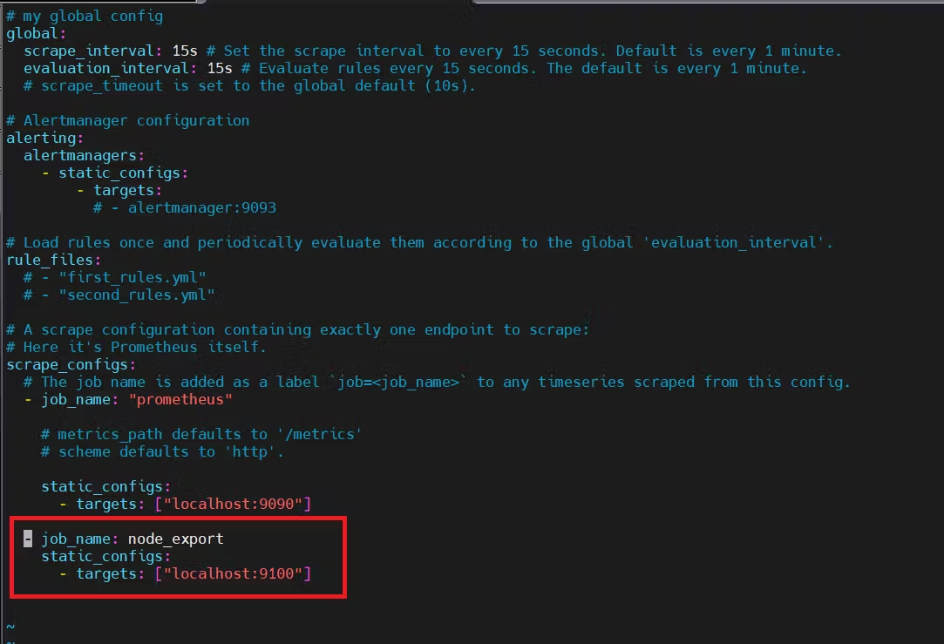

**Before, restarting check if the config is valid.**

* promtool check config /etc/prometheus/prometheus.yml
* 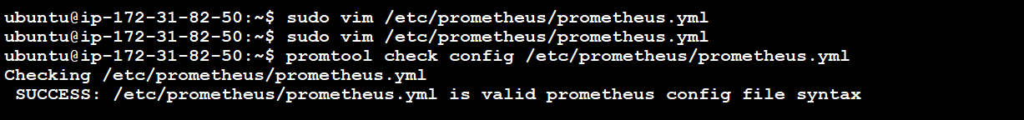

**you can use a POST request to reload the config.**

* curl -X POST <http://localhost:9090/-/reload>



K. **Run this on your browser**: http://<ip>:9090/targets

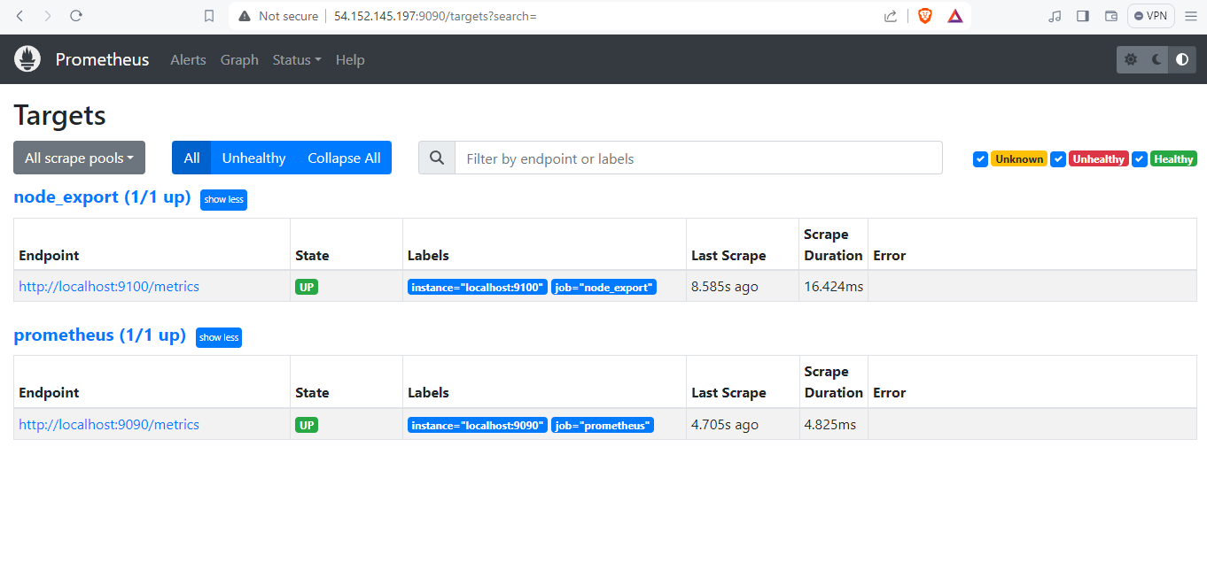

**Step 7: Install Grafana on Ubuntu 22.04.**

A. To visualize metrics we can use Grafana. There are many different data sources that Grafana supports, one of them is Prometheus. First, let's make sure that all the dependencies are installed.

* sudo apt-get install -y apt-transport-https software-properties-common

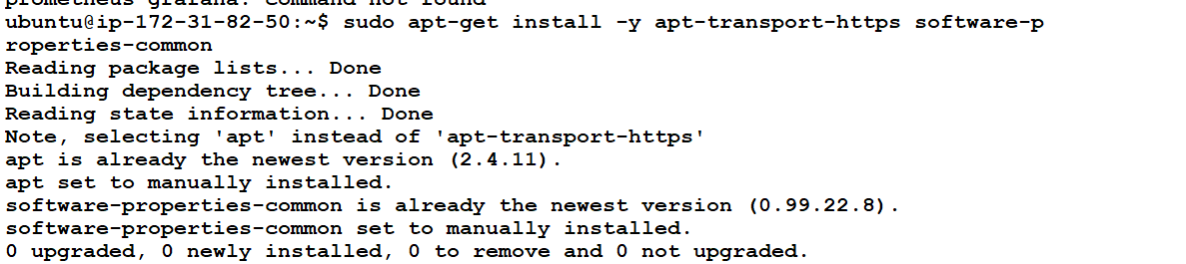

B. Next, add the GPG key.

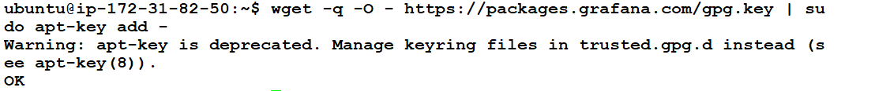

C. Add this repository for stable releases.

* echo "deb <https://packages.grafana.com/oss/deb> stable main" | sudo tee -a /etc/apt/sources.list.d/grafana.list



D. Now run these:

* sudo apt-get update
* sudo apt-get -y install grafana
* 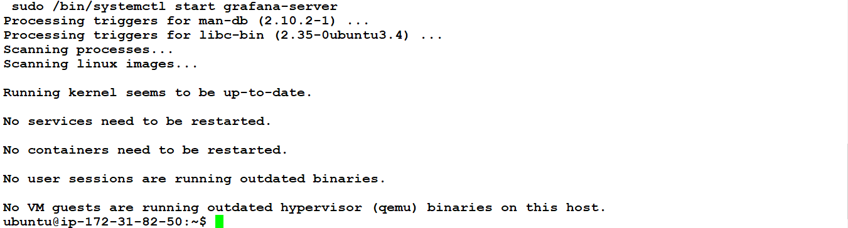
* sudo systemctl enable grafana-server
* sudo systemctl start grafana-server
* sudo systemctl status grafana-server
* 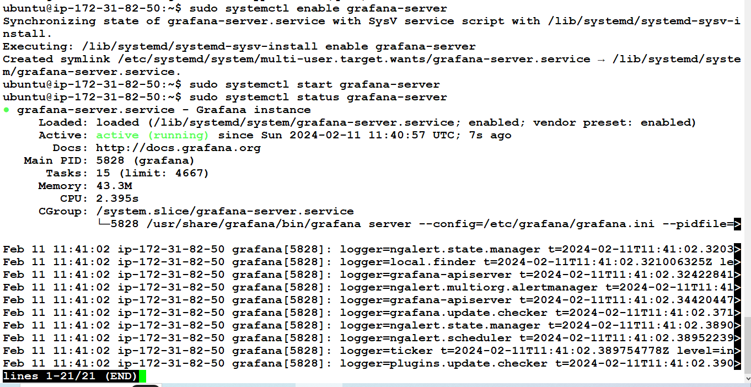

E. Go to http://<ip>:3000 and log in to the Grafana using default credentials. The username is admin, and the password is admin as well.

* username admin
* password admin

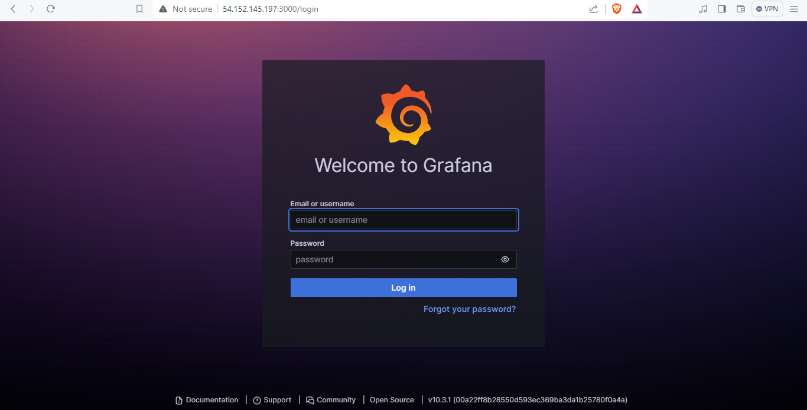

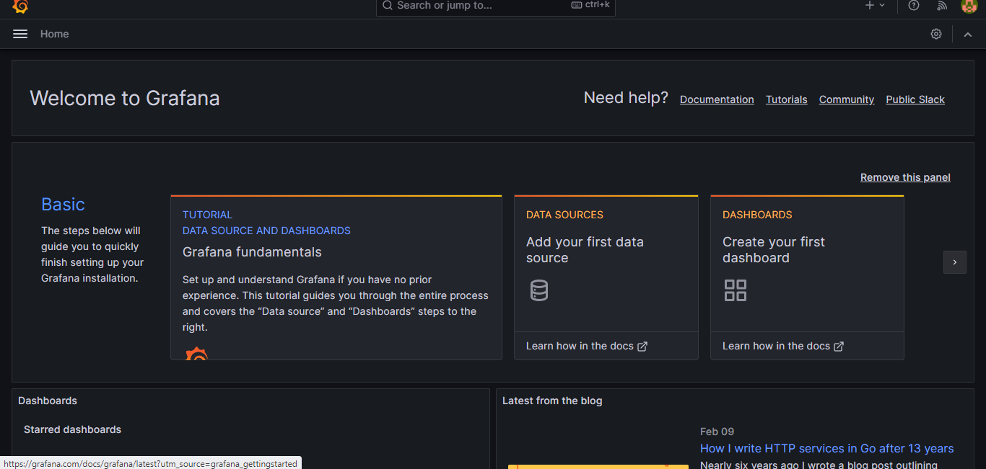

F. To visualize metrics, you need to add a data source first. Click on **DATA SOURCES**...

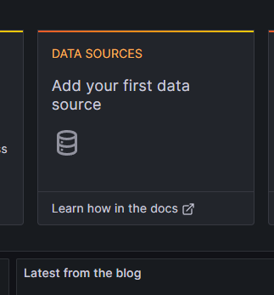

Click on **prometheus**:

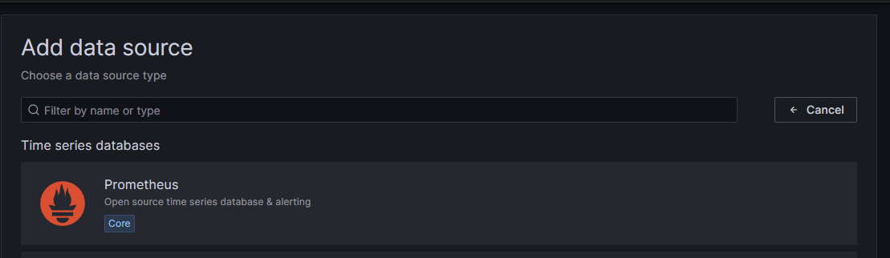

G. For the URL, enter <public-ip:9090>

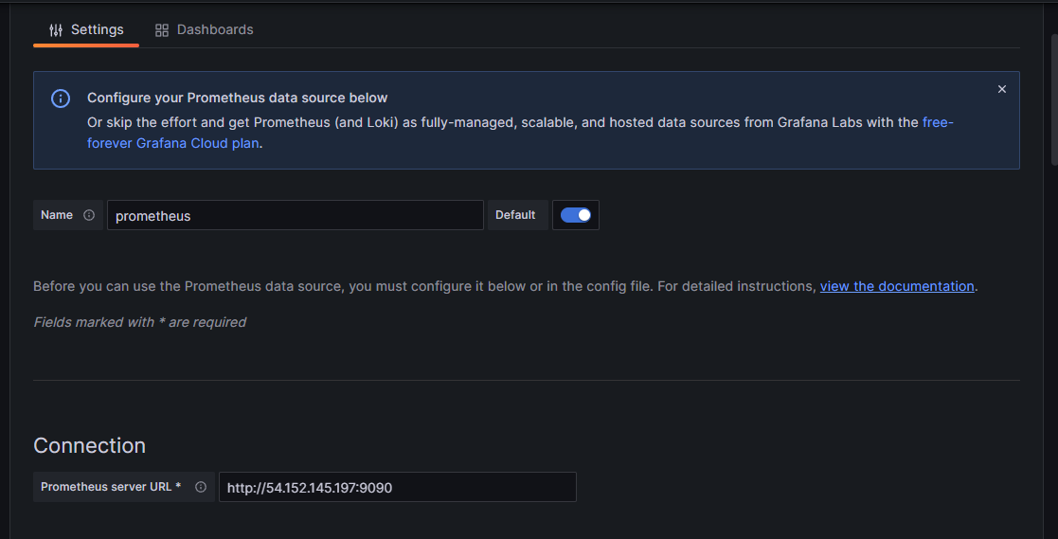

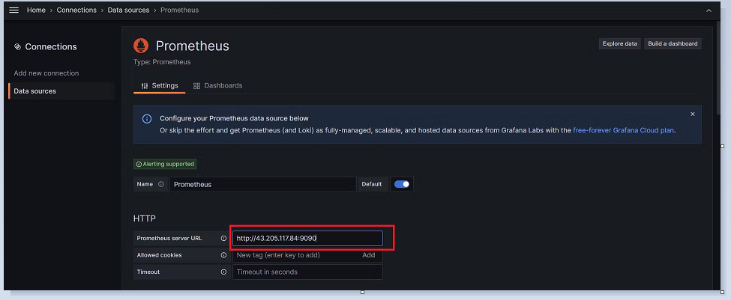

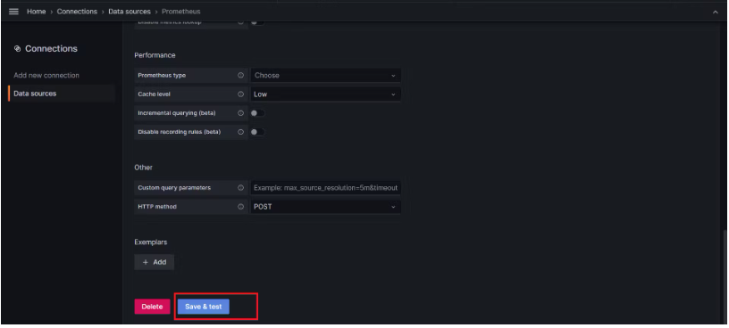

H. Let's add Dashboard for a better view.

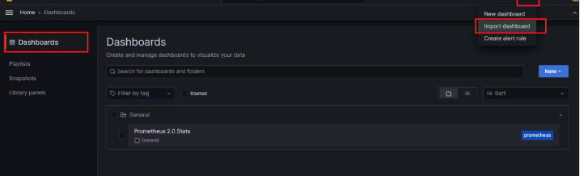

I. Click on Import Dashboard paste this code **1860** and click on load.

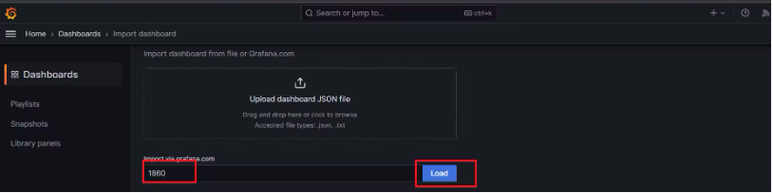

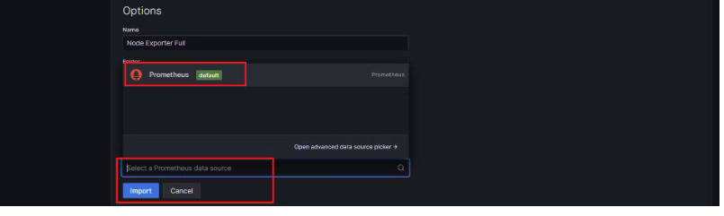

J. You will see this output:

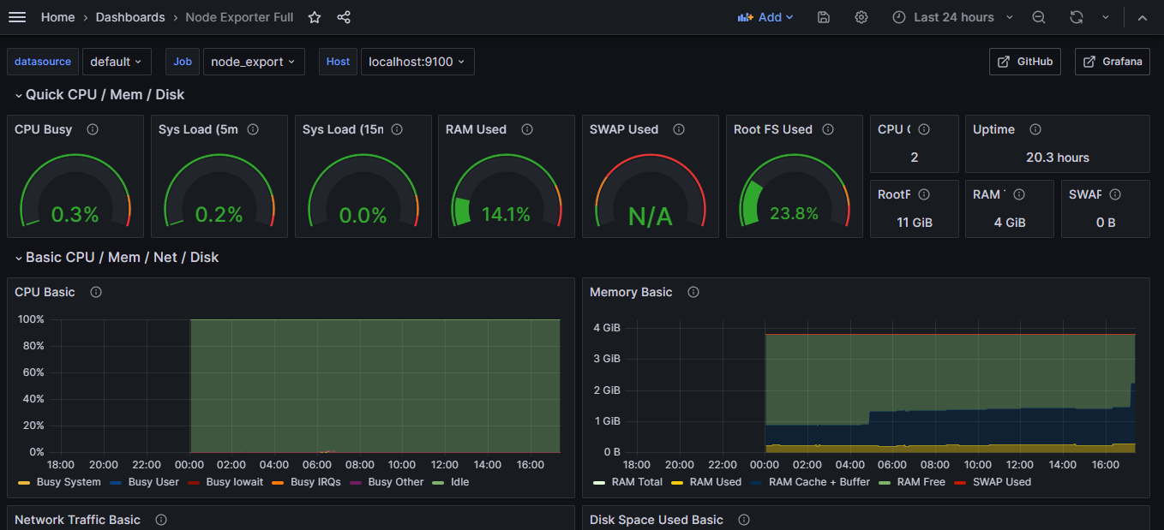

**Step 8: Install the Prometheus Plugin and Integrate it with the Prometheus server**

A. Let's Monitor JENKINS SYSTEM

* Need Jenkins up and running machine
* Goto Manage Jenkins --> Plugins --> Available Plugins
* Search for Prometheus and install it

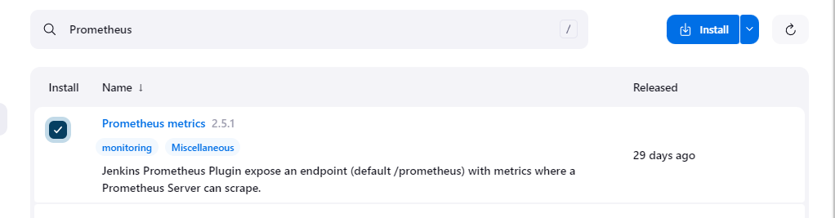

Once that is done. Go to Dashboard---Manage jenkins---system search for path(prometheus) is set to /Prometheus path in system configurations:

**Apply and save.**

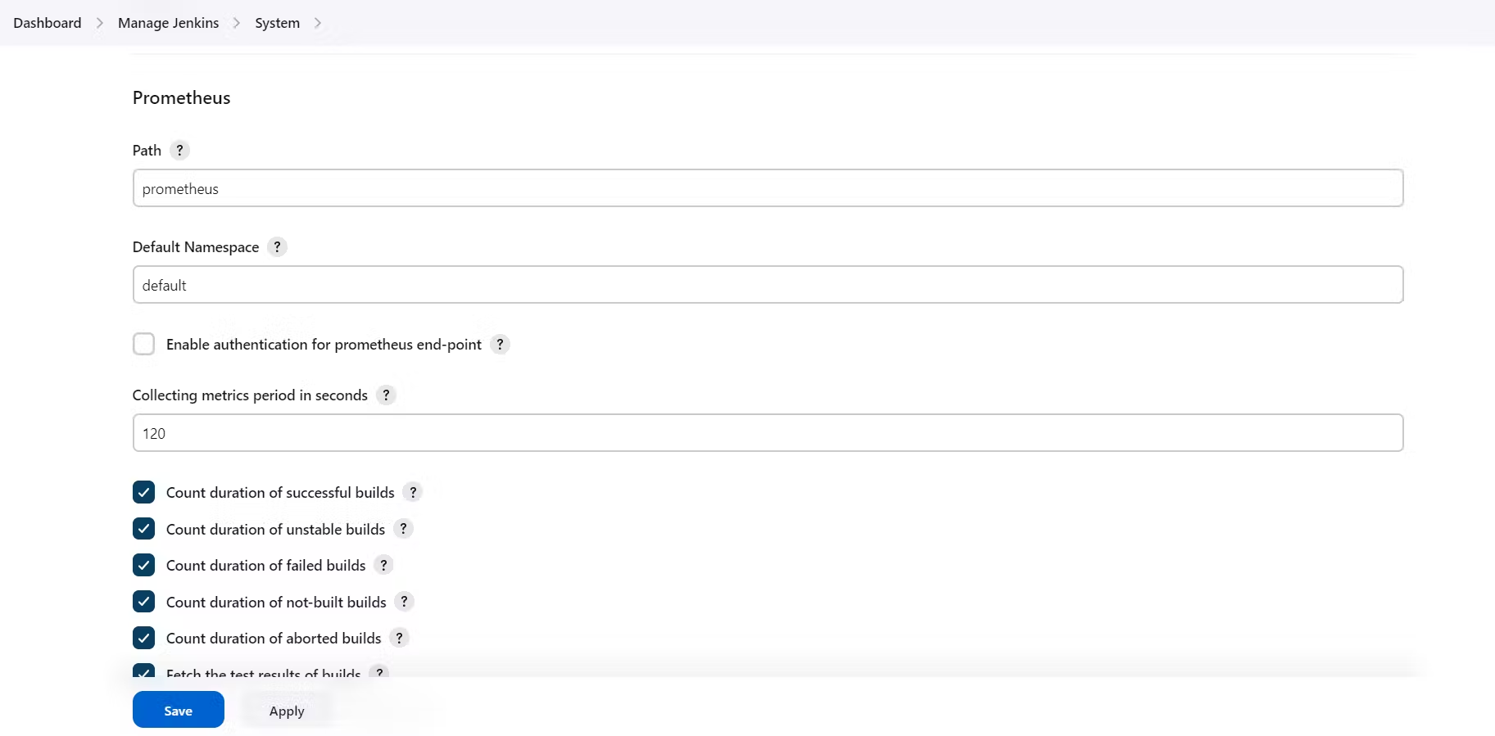

**B.** To create a static target, you need to add job_name with static_configs. go to Prometheus server:

* sudo vim /etc/prometheus/prometheus.yml
* Insert below data inside the same file:

- job_name: 'jenkins'

metrics_path: '/prometheus'

static_configs:

- targets: ['<jenkins-ip>:8080']

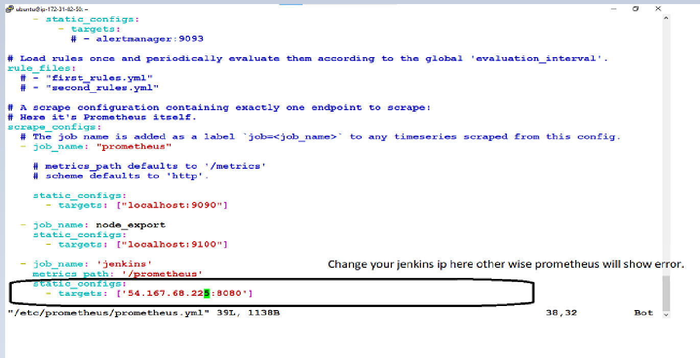

C. Before, restarting check if the config is valid.



D. Then, you can use a POST request to reload the config.

* curl -X POST <http://localhost:9090/-/reload>

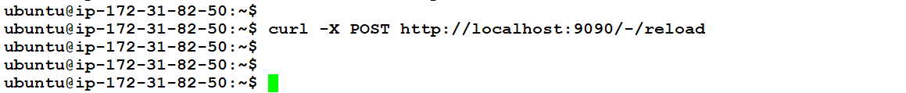

E. Check the targets section:

* http://<ip>:9090/targets

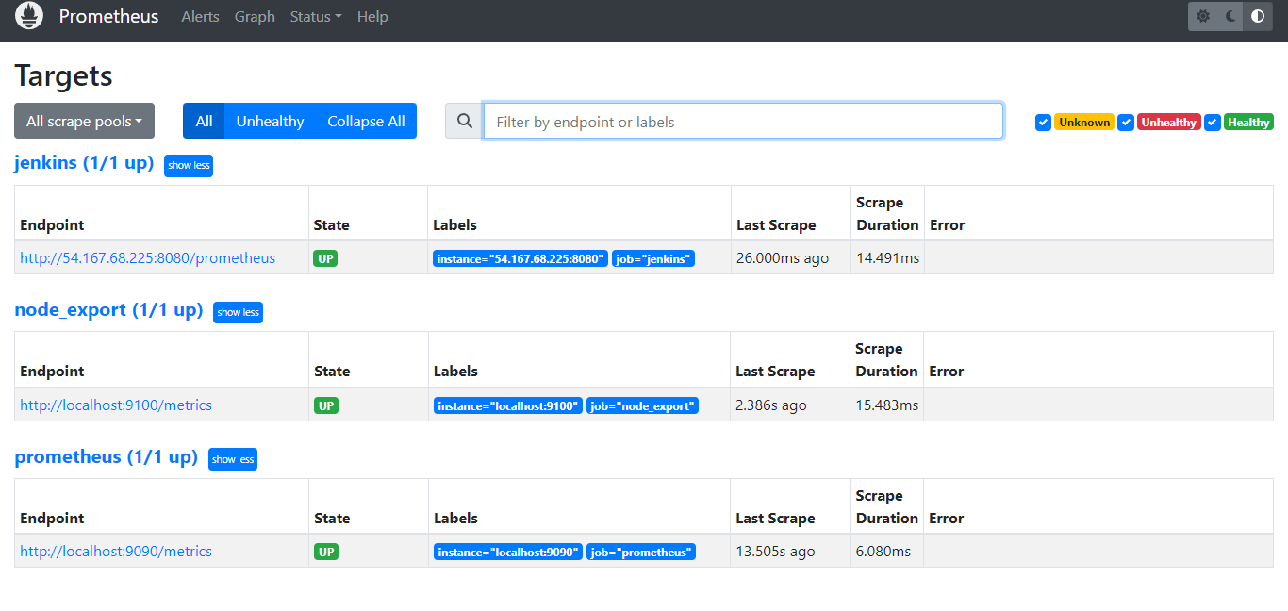

**F.Let's add Dashboard for a better view in Grafana.**

Click On Dashboard --> + symbol --> Import Dashboard & Use Id 9964 and click on load.

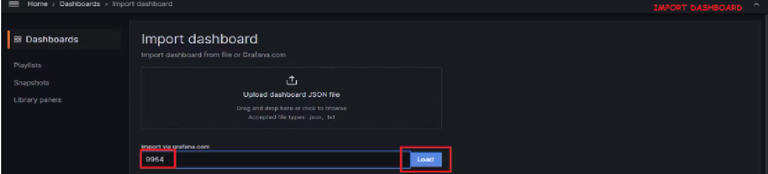

Select the data source and click on Import

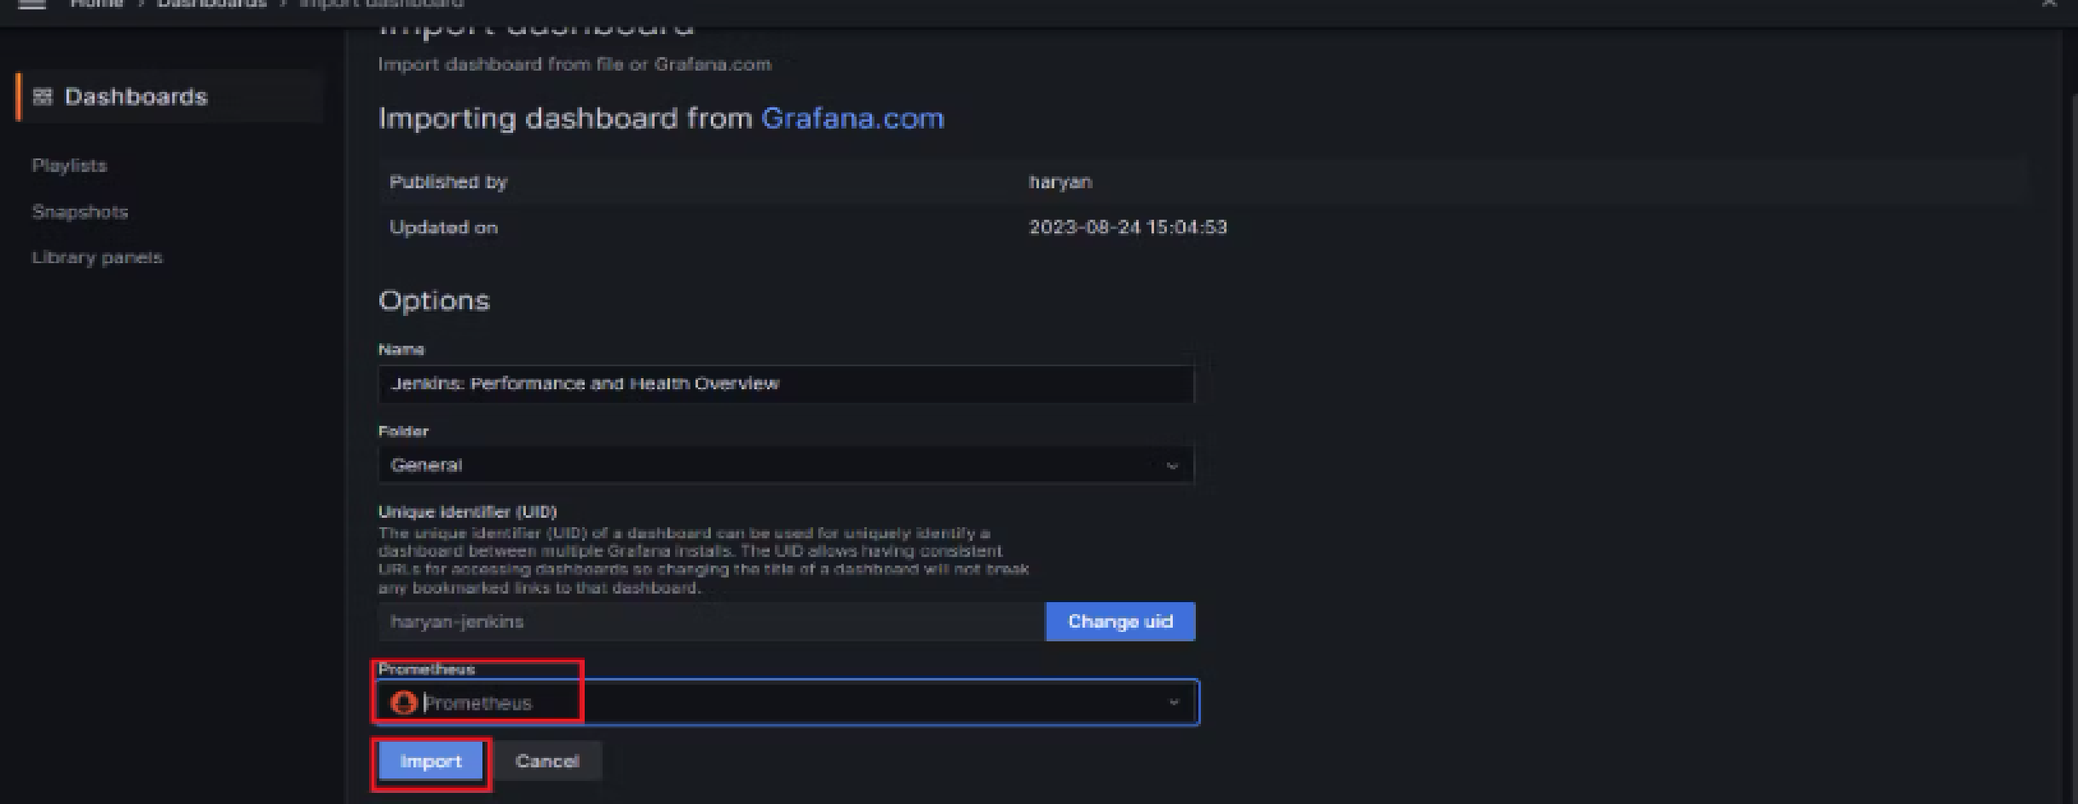

G. Now you will see the Detailed overview of Jenkins.

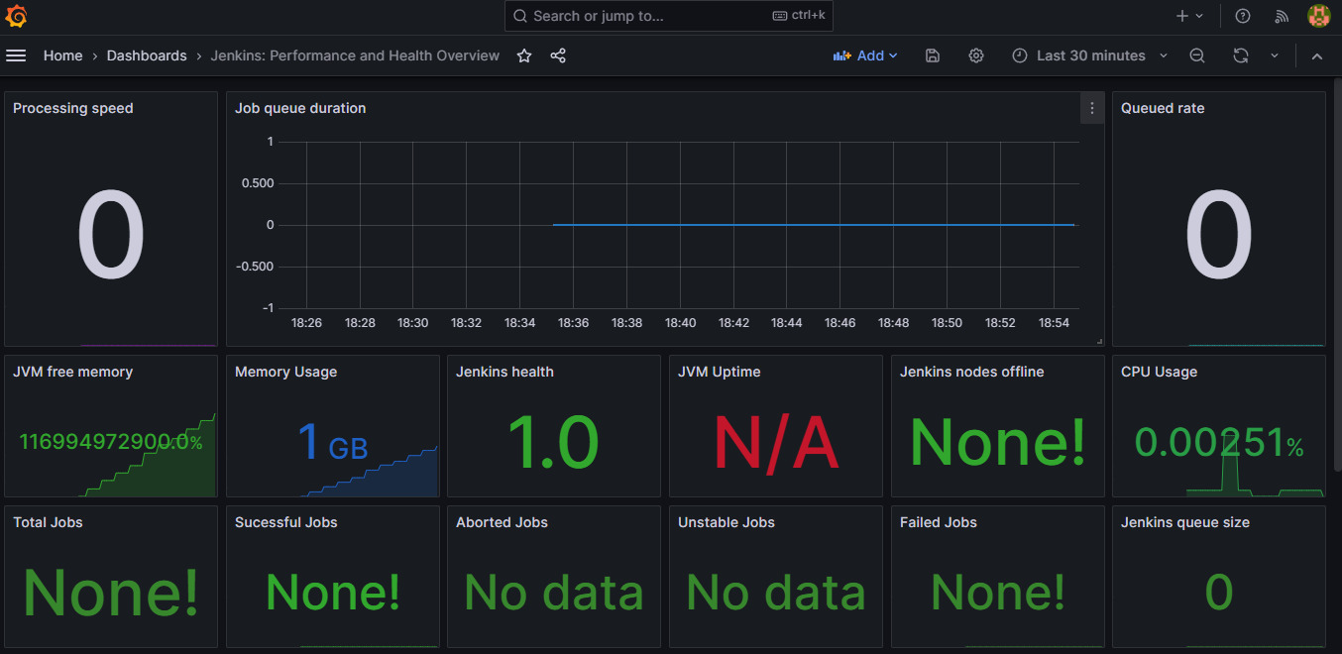

**Step 9: Email Integration With Jenkins and Plugin Setup.**

A. Install **Email Extension** Plugin in Jenkins.

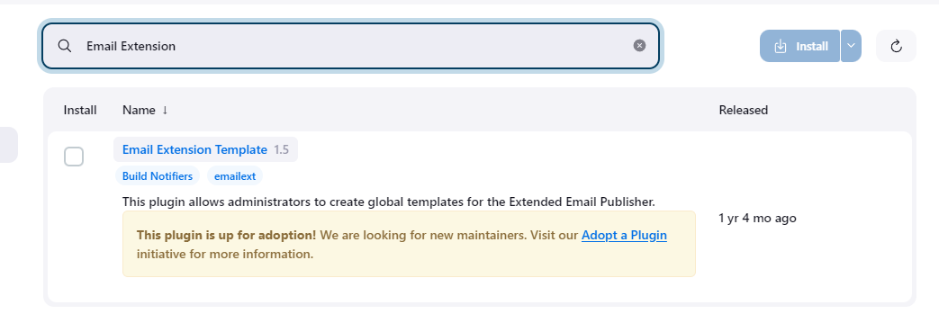

B. Go to your Gmail and click on your profile: Then click on Manage Your Google Account --> click on the security tab on the left side panel you will get this page(provide mail password).

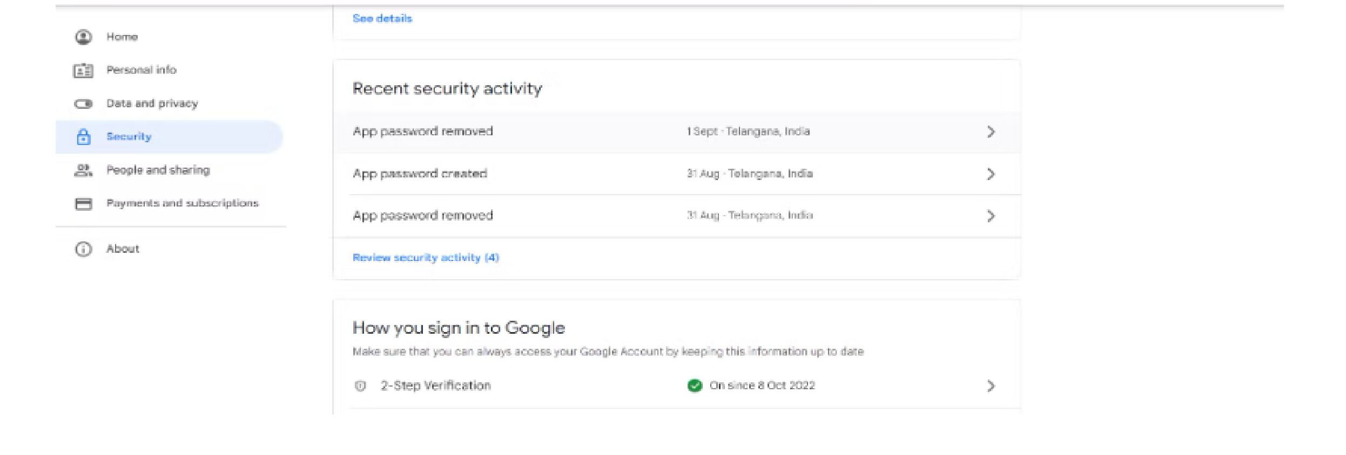

**2-step verification should be enabled. Search for the app in the search bar you will get app passwords like the below image.**

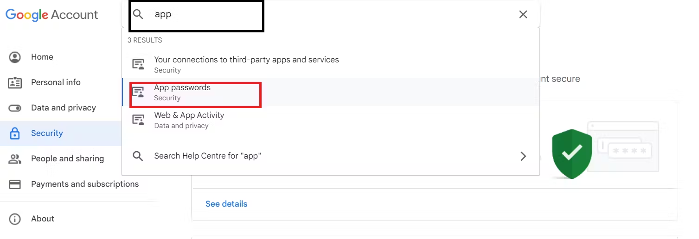

**Click generate:**

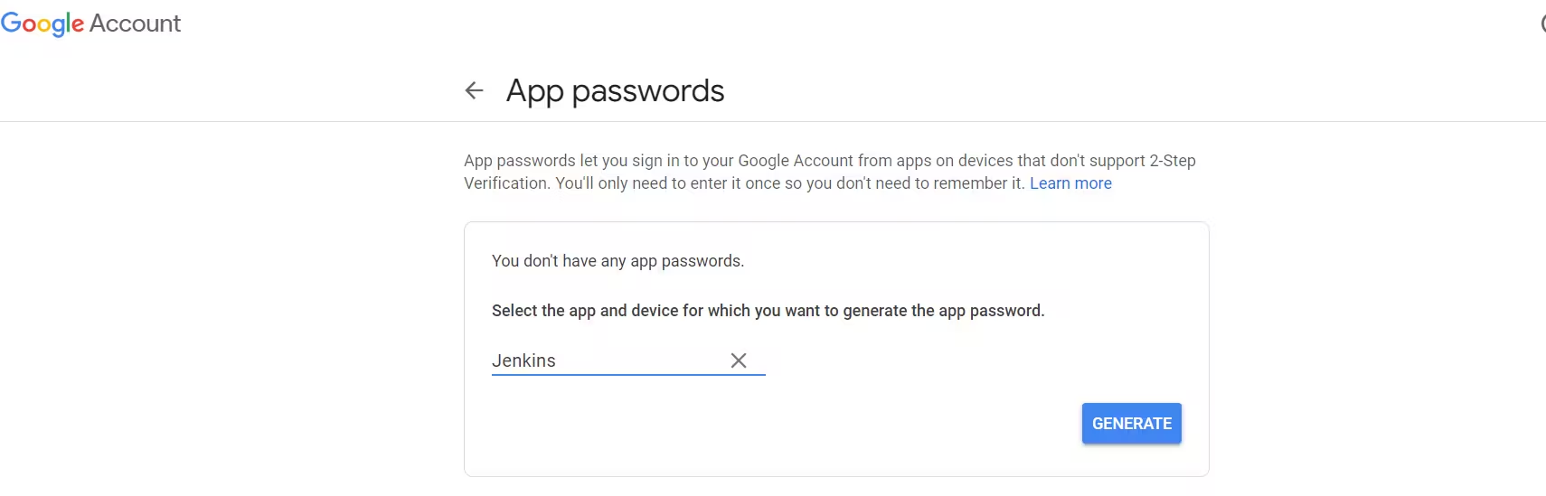Copy it and click done:

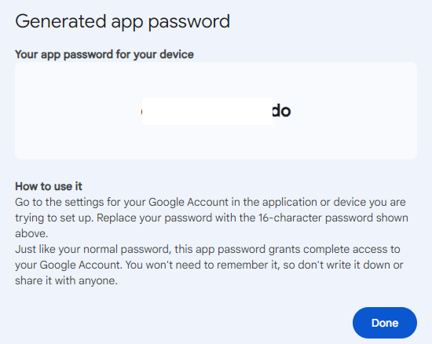

C. Go to Manage jenkins



--scroll down to credentials---

Global--toggle down--add credentials:

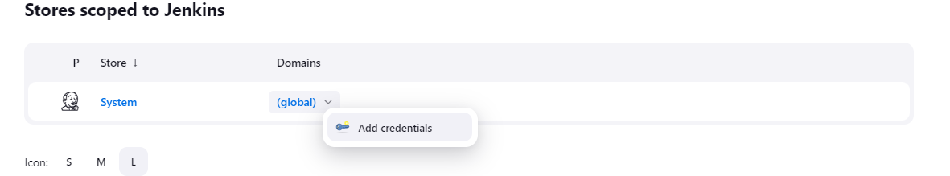

username: your email then provide the password retrived from google account security, yes that token, example: ecsz ufgj vtoj sado

id :mail

Desc: mail, then click on create:

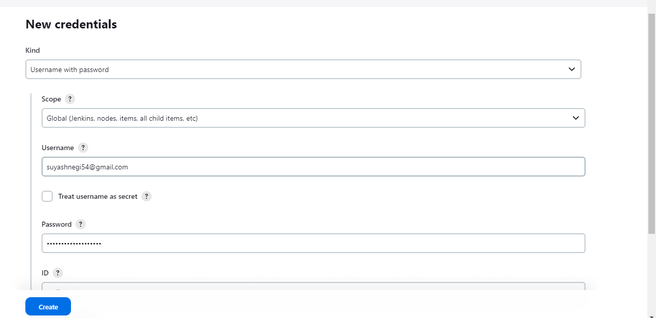

D.Once the plugin is installed in Jenkins, click on manage Jenkins --> configure system there under the E-mail Notification section configure the details as shown in the below images:

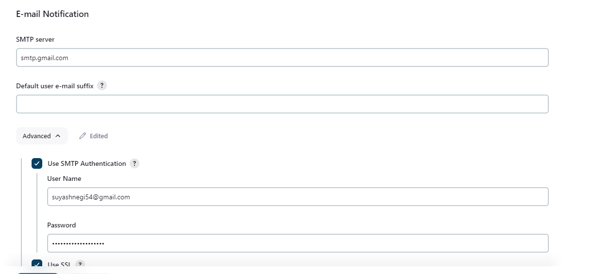

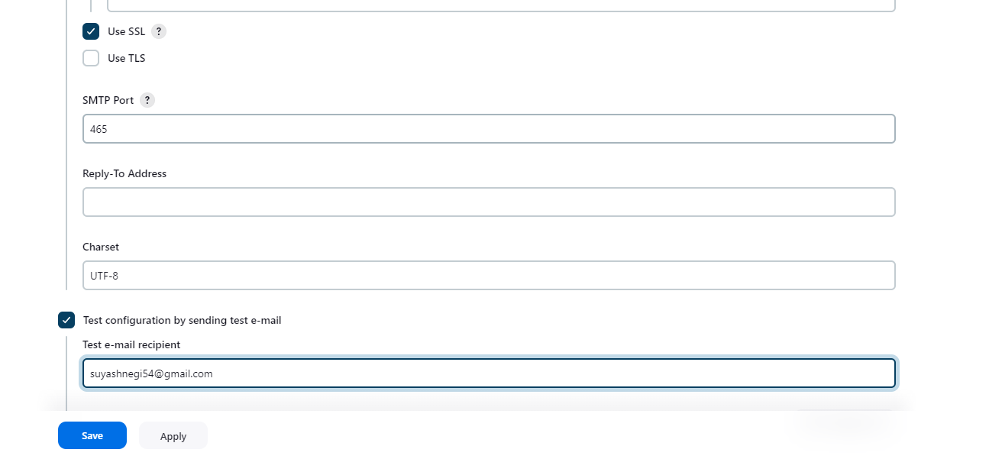

Click on test and apply:

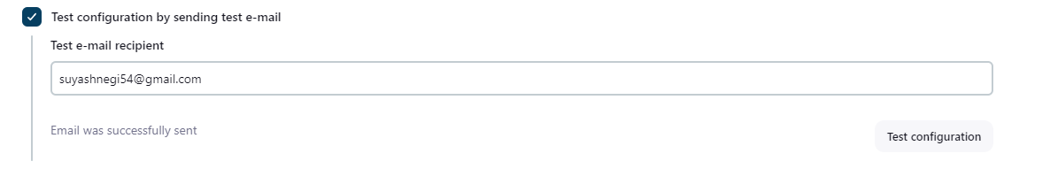



Go up we need to add credentials in one more section in the same page:

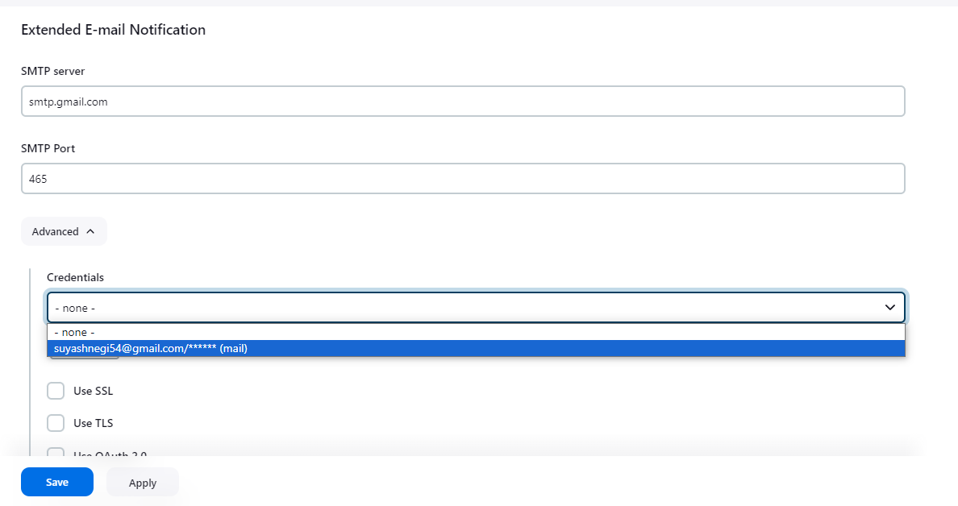

Enable ssl

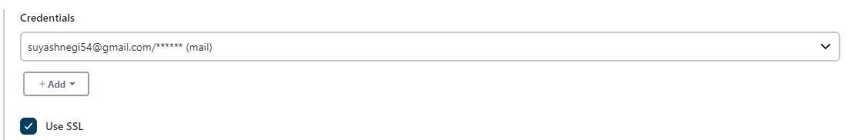

Go down little more change dflt content type to html

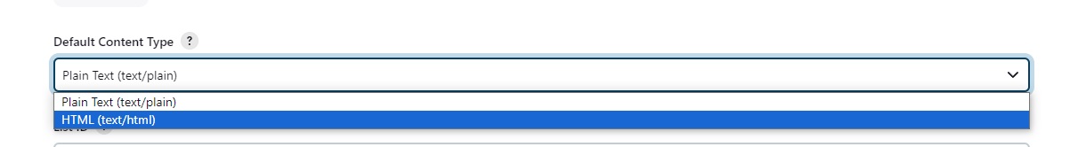

Scroll down and look for triggers: and click always

Apply and save.

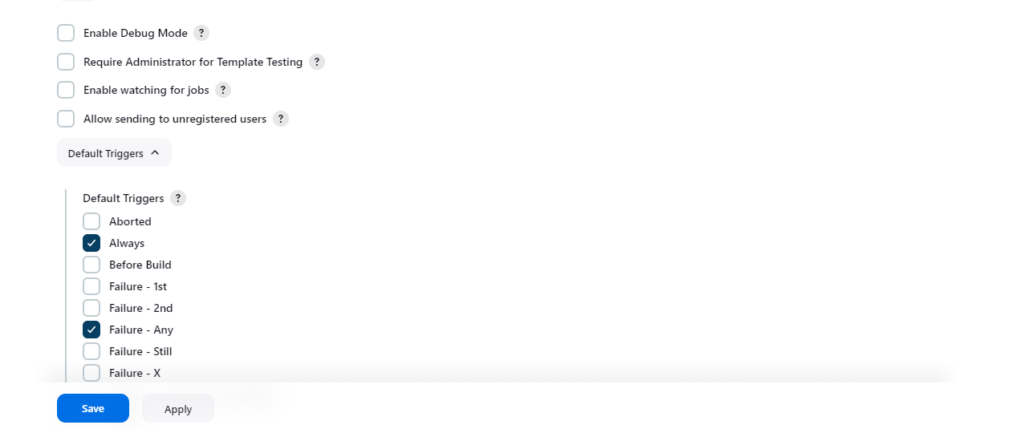

**Step 10: — Install Plugins like JDK, Sonarqube Scanner, NodeJs, OWASP Dependency Check.**

A. Install Plugins,

Goto Manage Jenkins →Plugins → Available Plugins →Install below plugins:

1 → Search and select : Eclipse Temurin Installer

2 → Search and select : SonarQube Scanner

3 → Search and select : NodeJs Plugin and click install, it will install all three plugins at once

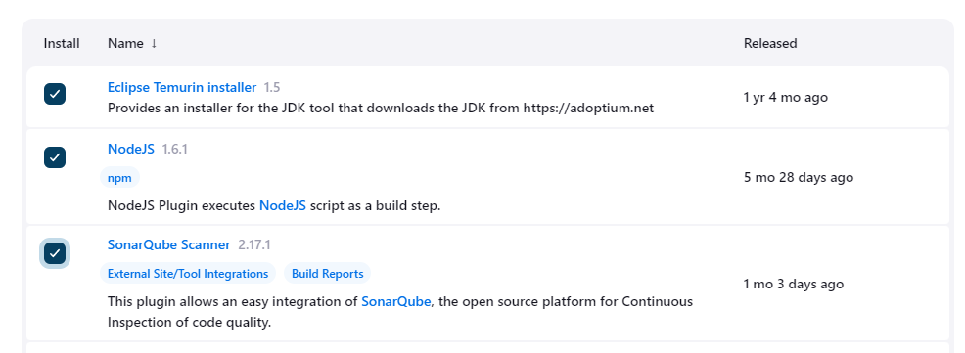

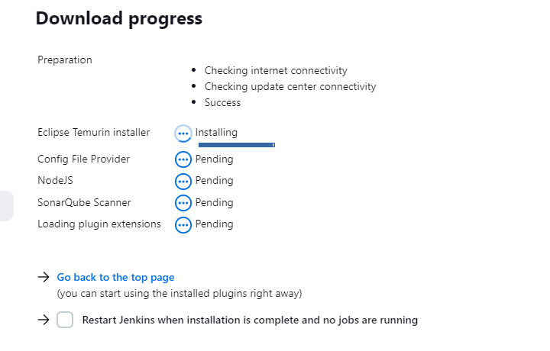

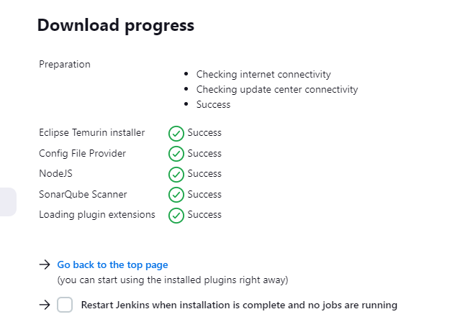

**B. Go to manage jenkins---tools**

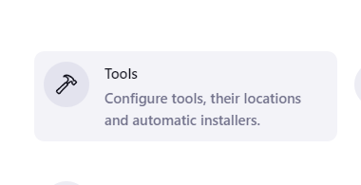

Give Name-jdk17 and click on install automatically

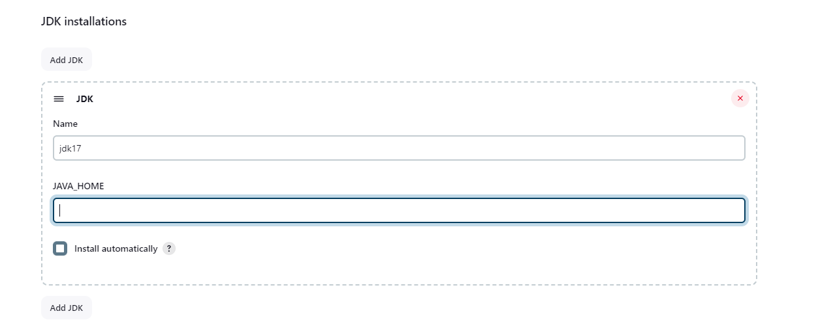

**Install fromadoptium and select jdk.17.0.8.1+1**

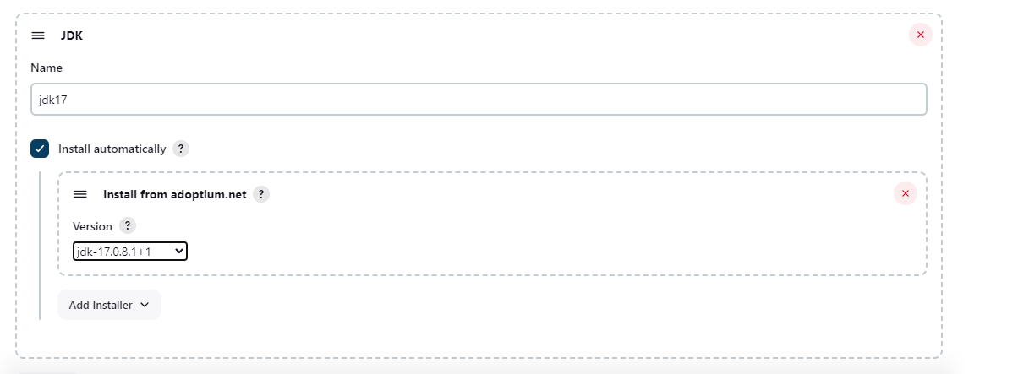

**Scroll down and click on add NodeJS:**

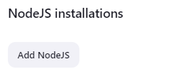

Name : node16

Version : 16.2.0-------------then click apply and save.

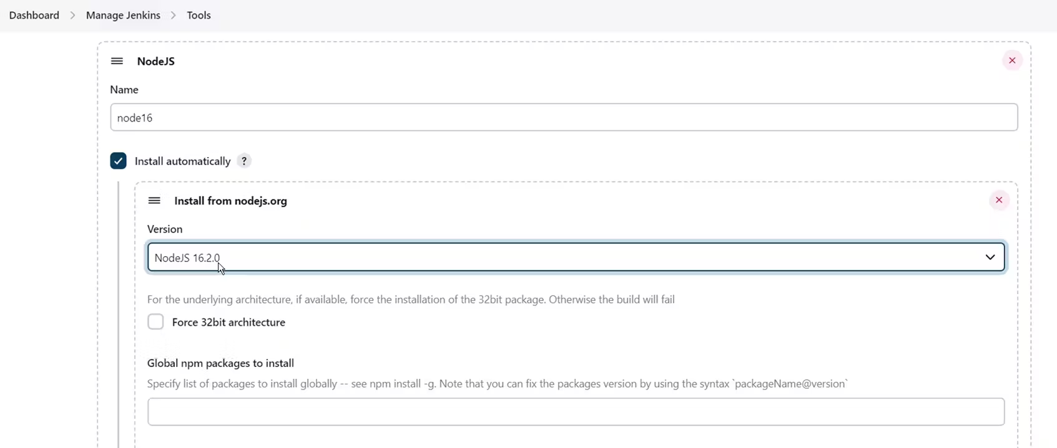

**Step 11: Configure Sonar Server in Manage Jenkins.**

We need to generate a token.

**A. Grab the Public IP Address of your EC2 Instance.**

Sonarqube works on Port 9000, so <Public IP>:9000. Goto your Sonarqube Server. Click on Administration → Security → Users → Click on Tokens and Update Token → Give it a name → and click on Generate Token

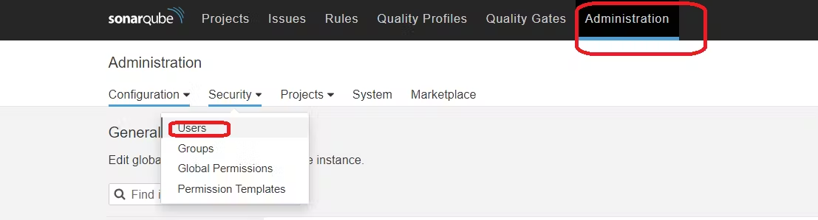

**Hover over tokens and click on hamburger menu-update token.**

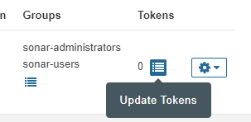

Name: jenkins click on generate: and copy and store it somewhere safe.

example : squ_28e8a7846191542ddd9a007c2978fd4e08062cd1

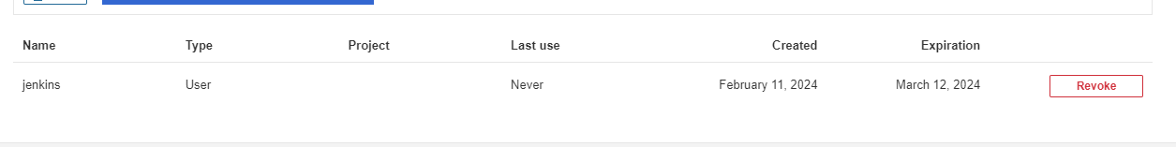

**B. Go to Jenkins Dashboard → Manage Jenkins → Credentials →Global--toggle down--add credentials:**



**Add Secret Text. It should look like this:**

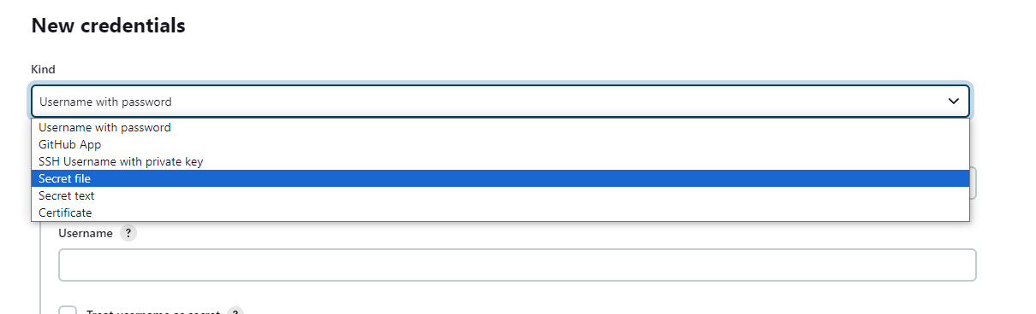

Secret : squ_28e8a7846191542ddd9a007c2978fd4e08062cd1(You should use your own sonar token) and rest insert same details then create:

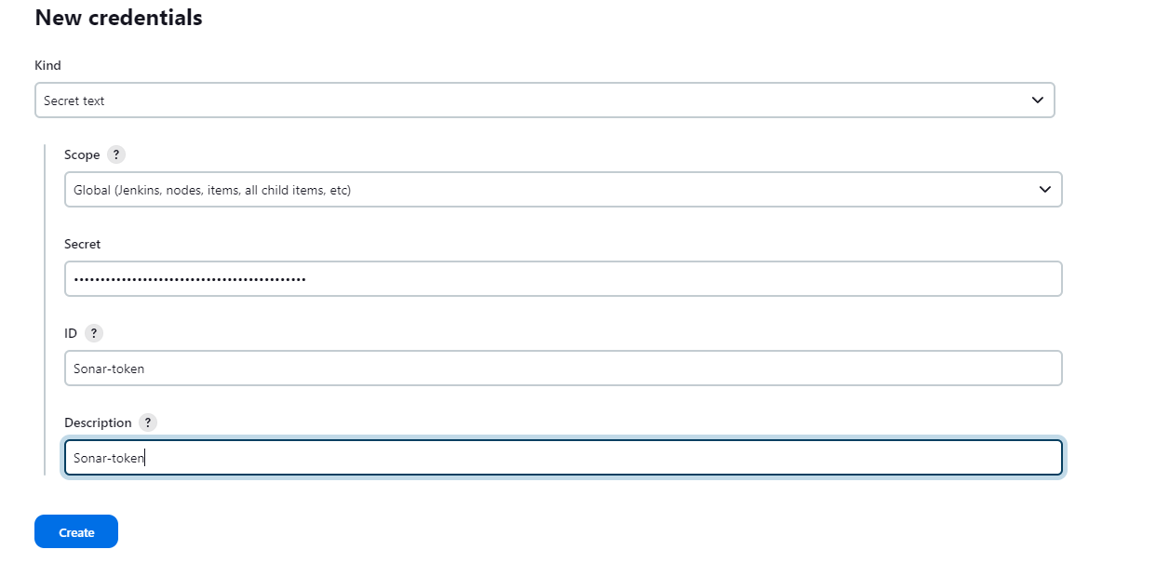



C. Now, go to Dashboard → Manage Jenkins → System and Add Sonar servers and details like the below image.

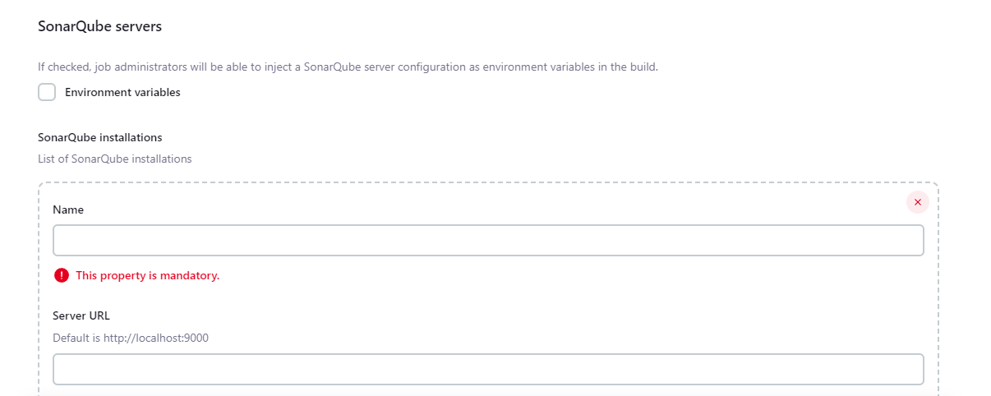

Add these details--server url is sonar-qube instance url:9000 and then hit apply and save

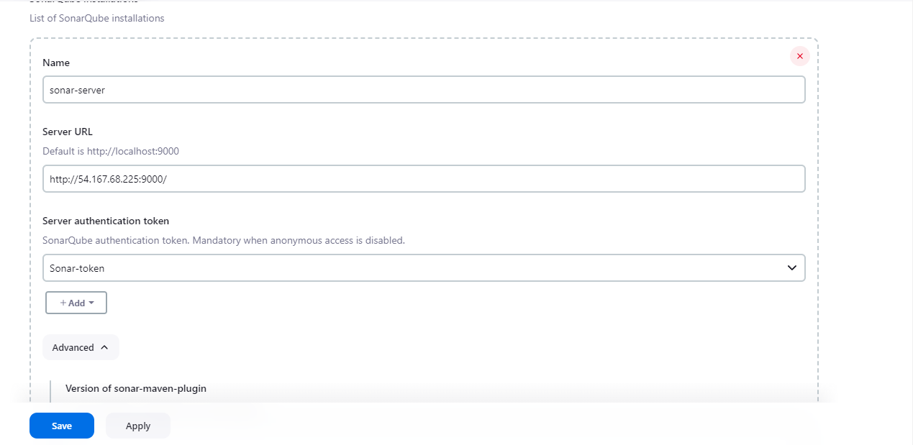

D.The Configure System option is used in Jenkins to configure different server. Global Tool Configuration is used to configure different tools that we install using Plugins, We will install a sonar scanner in the tools. Click on add sonar cube scanner:

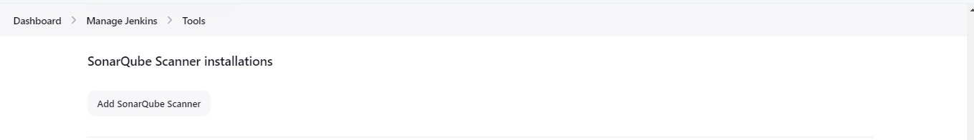

Do same changes click on apply and save:

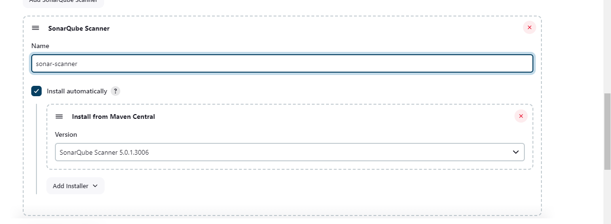

**Step 12: In the Sonarqube Dashboard add a quality gate also:**

**A. Go to sonarqube then administration then configuration then wenhooks:**

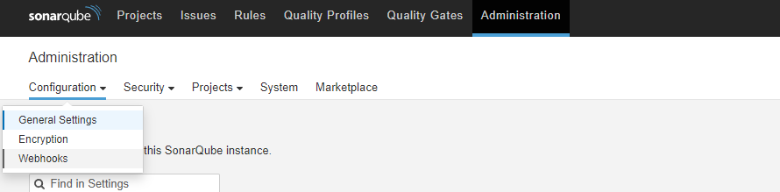

**Click on create and povide the same details then click on create:**

<http://jenkins-public-ip:8080/sonarqube-webhook/>

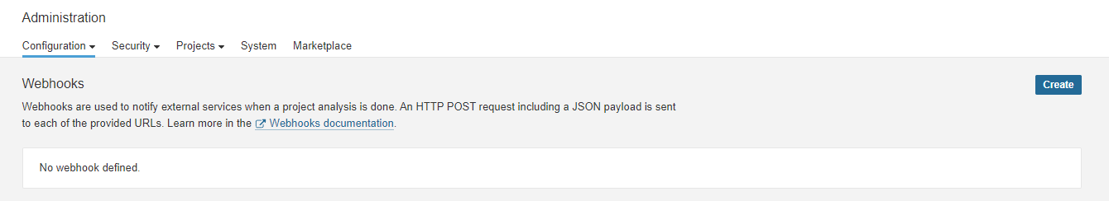

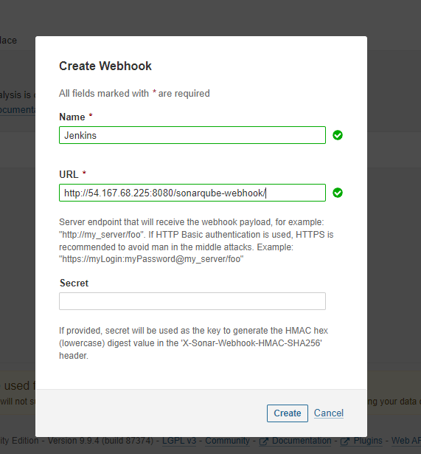

**Result:**

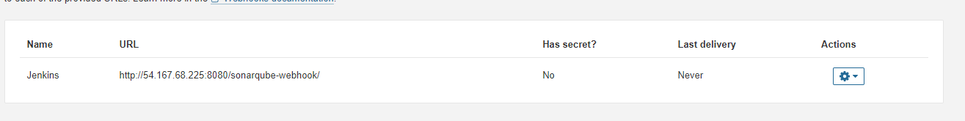

**Step 13: Setting up Netflix pipeline:**

**A. Go to New item:**

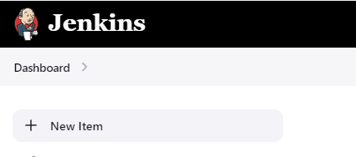

B. Enter name as Netflix, then select Pipeline and then click "ok":

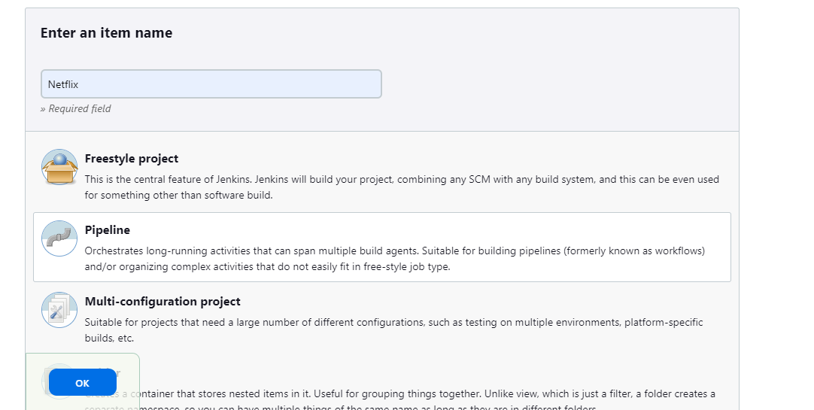

**C. Provide description as Netflix, then discard old builds and then scroll down to provide pipeline code:**

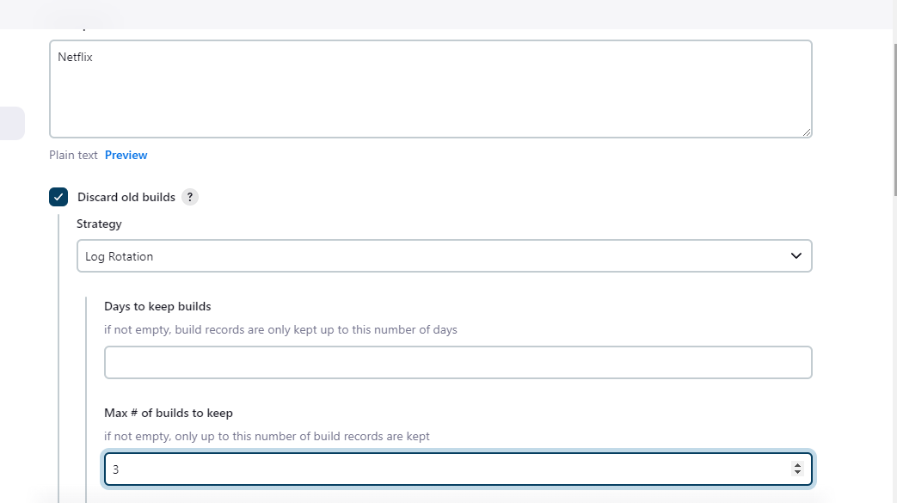

**Scroll down insert this as your pipeline code, note: do not forget to change your email id here in the pipeline script then save and apply.**

pipeline{

agent any

tools{

jdk 'jdk17'

nodejs 'node16'

}

environment {

SCANNER_HOME=tool 'sonar-scanner'

}

stages {

stage('clean workspace'){

steps{

cleanWs()

}

}

stage('Checkout from Git'){

steps{

git branch: 'main', url: '<https://github.com/Aj7Ay/Netflix-clone.git>'

}

}

stage("Sonarqube Analysis "){

steps{

withSonarQubeEnv('sonar-server') {

sh ''' $SCANNER_HOME/bin/sonar-scanner -Dsonar.projectName=Netflix \

-Dsonar.projectKey=Netflix '''

}

}

}

stage("quality gate"){

steps {

script {

waitForQualityGate abortPipeline: false, credentialsId: 'Sonar-token'

}

}

}

stage('Install Dependencies') {

steps {

sh "npm install"

}

}

}

post {

always {

emailext attachLog: true,

subject: "'${currentBuild.result}'",

body: "Project: ${env.JOB_NAME}<br/>" +

"Build Number: ${env.BUILD_NUMBER}<br/>" +

"URL: ${env.BUILD_URL}<br/>",

to: '**suyashnegi54@gmail.com**',

attachmentsPattern: 'trivyfs.txt,trivyimage.txt'

}

}

}

D. Start your first build: in first time it will take a lot more time to finish..

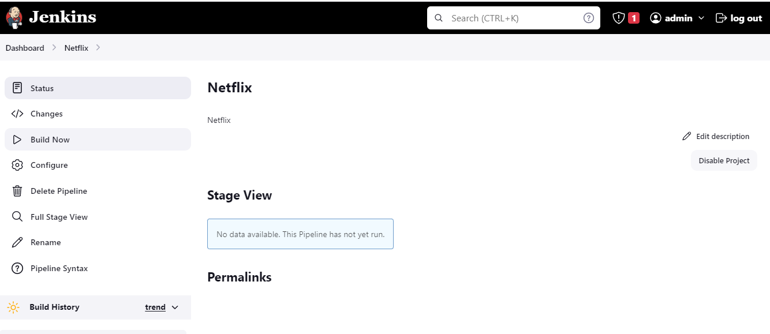

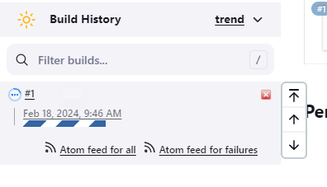

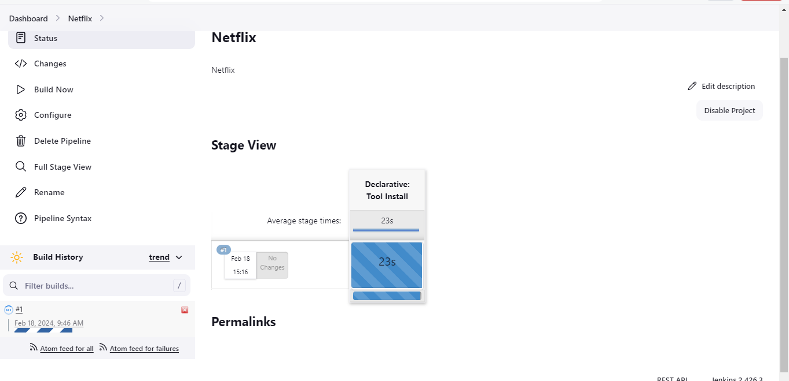

Note if you see failure in your build after git, then my suggestion is to check tools setup names they should always align with the names parsed in the pipelines:

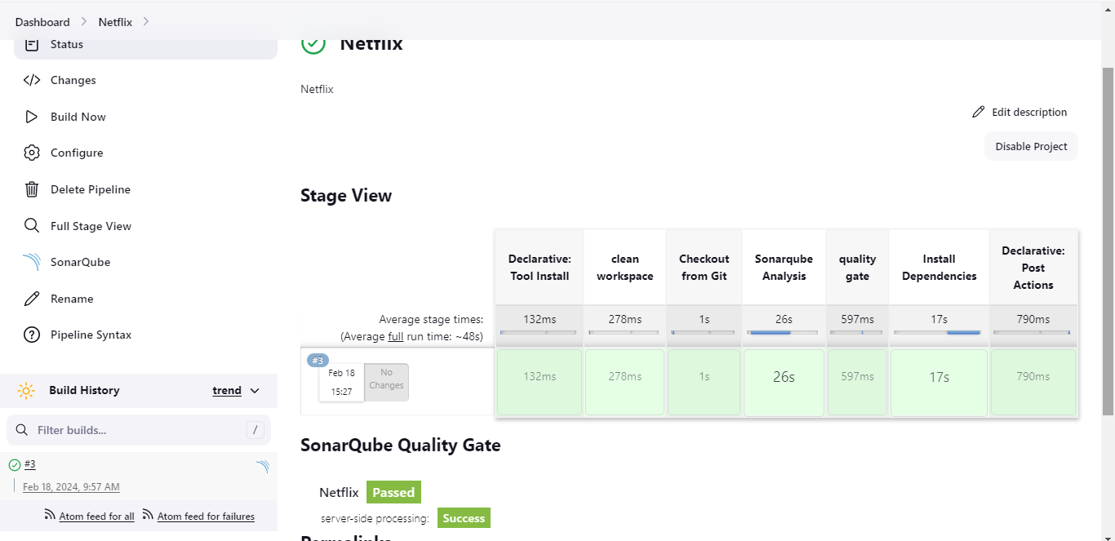

To see the report, you can go to Sonarqube Server and go to Projects.

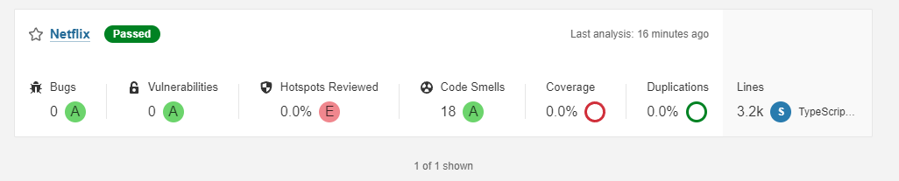

**Step 14: Install OWASP Dependency Check Plugins**

A. Go to Dashboard → Manage Jenkins → Plugins → OWASP Dependency-Check. Click on it and install it without restart.

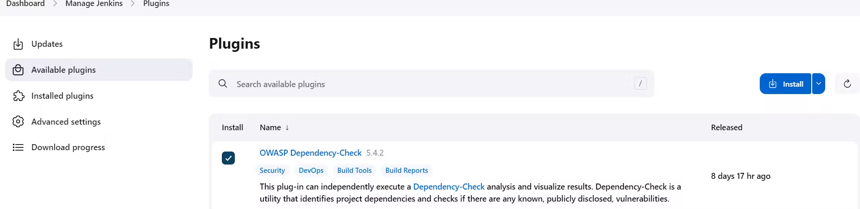

B. Next, we had to configure the Tool, Goto Dashboard → Manage Jenkins → Tools →

Provide name = DP-Check

click on install automatically.

Install from git hub .

Version will be 6.5.1, click apply and save.

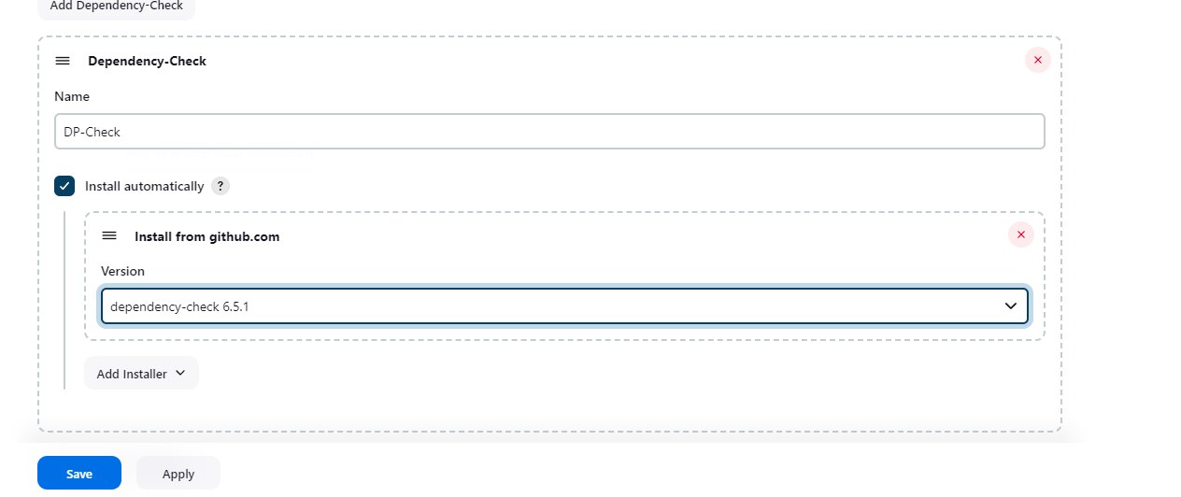

C. Now go configure → Pipeline and add this stage under rest stages to your pipeline and click apply save then build.

stage('OWASP FS SCAN') {

steps {

dependencyCheck additionalArguments: '--scan ./ --disableYarnAudit --disableNodeAudit', odcInstallation: 'DP-Check'

dependencyCheckPublisher pattern: '**/dependency-check-report.xml'

}

}

stage('TRIVY FS SCAN') {

steps {

sh "trivy fs . > trivyfs.txt"

}

}

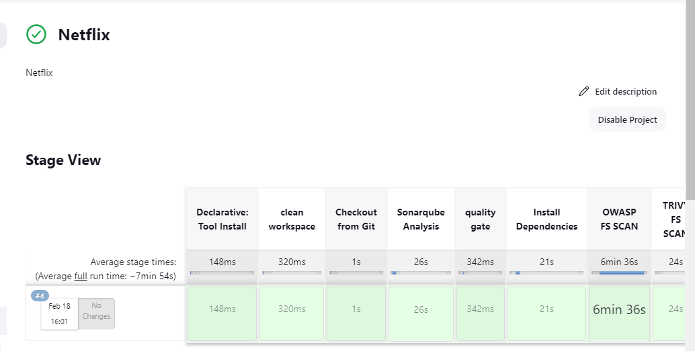

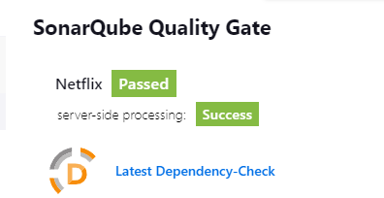

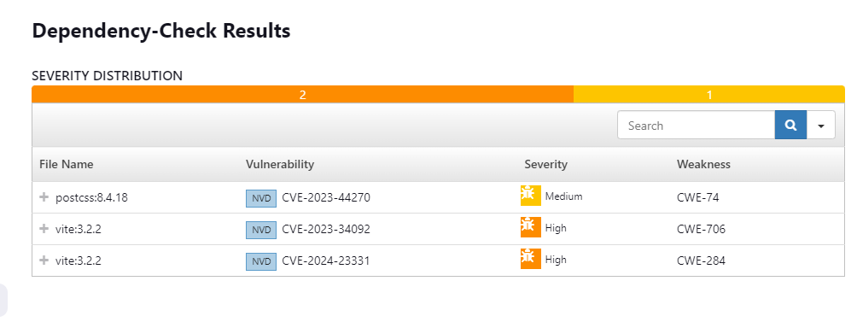

**Step 15: Docker Image Build and Push.**

A. We need to install the Docker tool in our system, Goto Dashboard → Manage Plugins → Available plugins → Search for Docker and install these plugins:

* Docker
* Docker Commons
* Docker Pipeline
* Docker API
* docker-build-step.
* 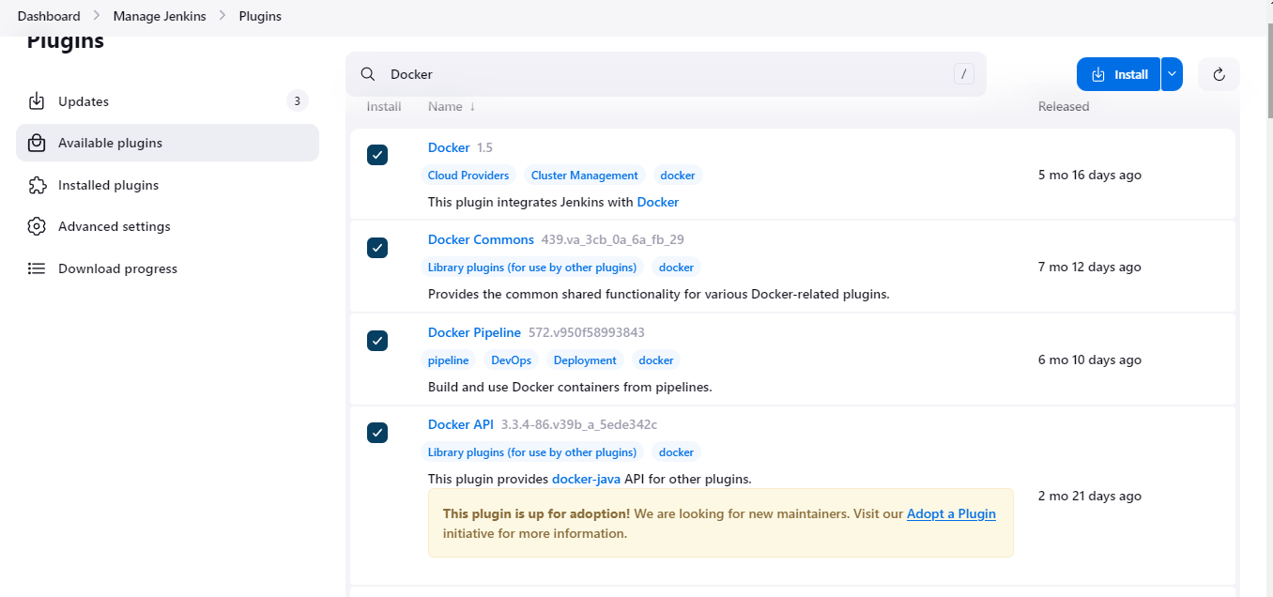

B. Add DockerHub Username and Password under Global Credentials.

id= docker

description= docker, create.

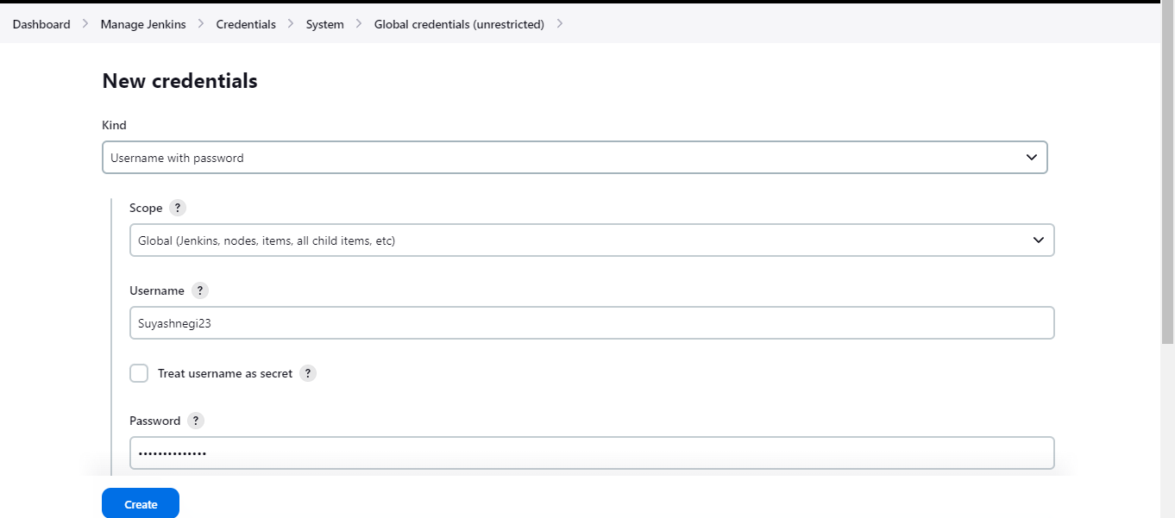

C. Now, goto Dashboard → Manage Jenkins → Tools →

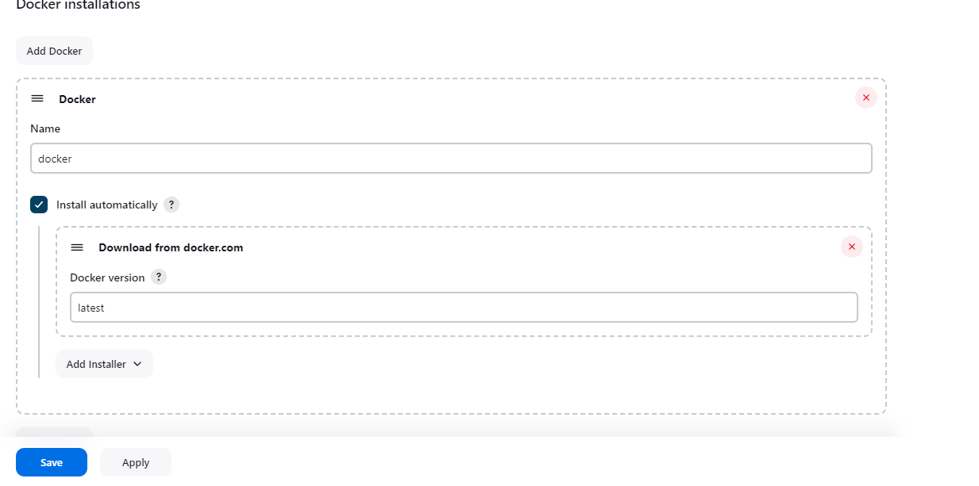

**Step 16: Building with out tmbd key**

A. Login to Jenkins server to verify run docker ps, it will show you sonarqube as a runnning container:

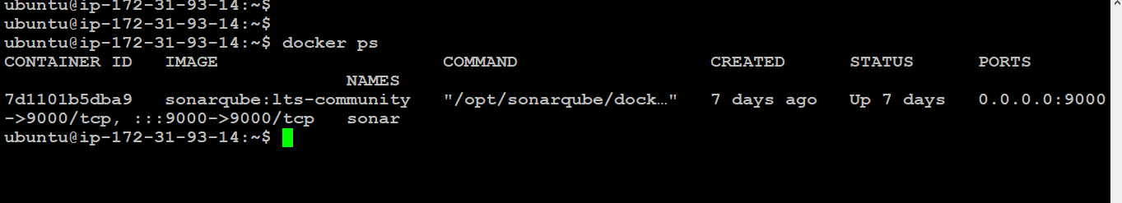

B. Go to : cd /var/lib/jenkins/workspace/Netflix/

And build a netflix image using this cmd: docker build -t netflix . ///// this means docker do a build with image name netflix and picking any docker file in this case.

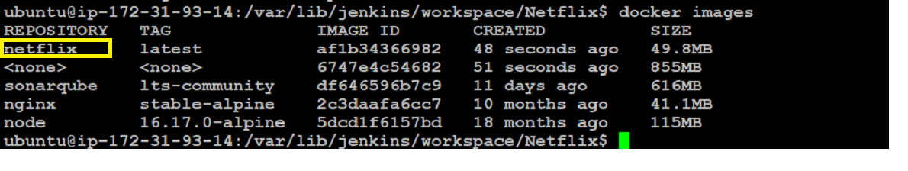

C. Now create a container from that image:

docker run -d --name netflix -p 8081:80 netflix:latest

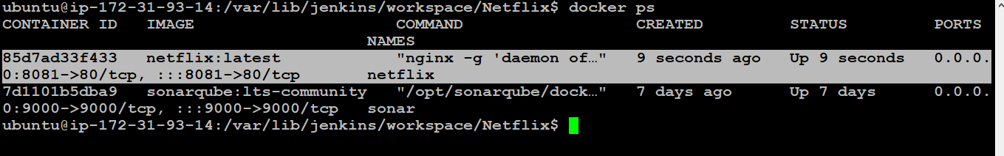

D. Goto your browser search ipaddof-your-jenkins-machine:8081, it will show this



Now inorder to get full working netflix version do:

docker stop netflix

docker rm netflix

**Step 17: Build with api key fully functional working website:**

A. Goto job-configure: pipeline, under stages inser this:

stage("Docker Build & Push"){

steps{

script{

withDockerRegistry(credentialsId: 'docker', toolName: 'docker'){

sh "docker build --build-arg TMDB_V3_API_KEY=XXXXXXXXXXXXXXXXXXXXXXXXX2 -t netflix ."

sh "docker tag netflix suyashnegi23/netflix:latest "

sh "docker push suyashnegi23/netflix:latest "

}

}

}

}

stage("TRIVY"){

steps{

sh "trivy image suyashnegi23/netflix:latest > trivyimage.txt"

}

}

stage('Deploy to container'){

steps{

sh 'docker run -d --name netflix -p 8081:80 suyashnegi23/netflix:latest'

}

}

Here, replace your user name and tmdb key.

Apply and save then build:

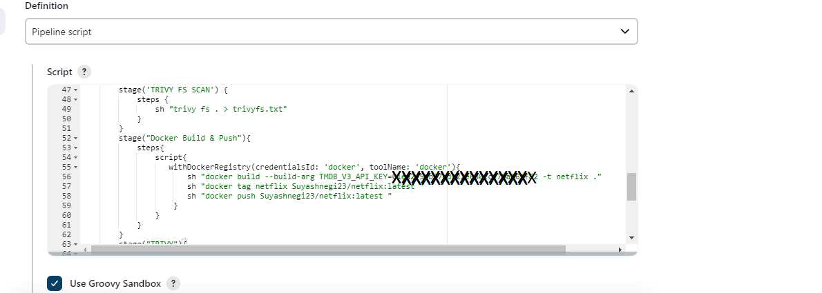

Result:

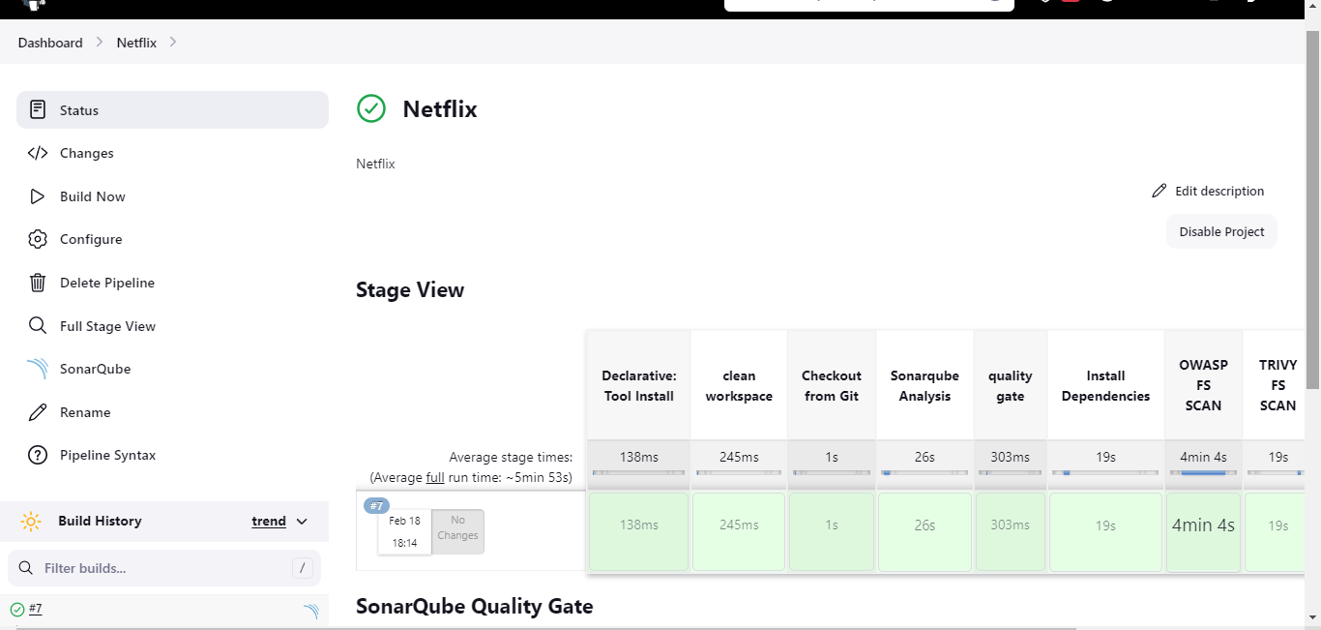

Image is also pushed at docker hub:

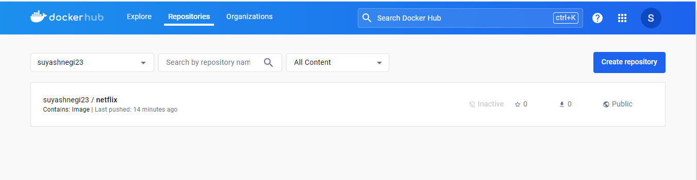

Container is also running:

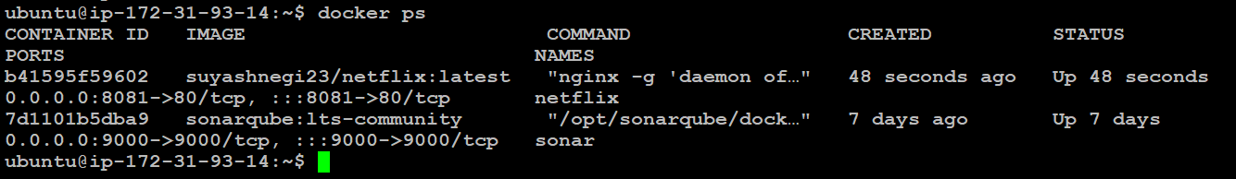

Final website:



you can also end your project here and add it in your resume or you can wish to deploy it in a kubernetes cluster also:

**Step 18: Kuberenetes Setup.**

A. Connect your machines to Putty, Take-Two Ubuntu 20.04 instances one for k8s master and the other one for worker. Install Kubectl on Jenkins machine also.

* Create a kueb.sh file by: sudo vim kube.sh
* Press i and paste the below:
* sudo apt update
* sudo apt install curl -y
* curl -LO <https://dl.k8s.io/release/$(curl> -L -s <https://dl.k8s.io/release/stable.txt)/bin/linux/amd64/kubectl>
* sudo install -o root -g root -m 0755 kubectl /usr/local/bin/kubectl
* kubectl version --client
* Press ESC + wq!
* chmod +x kube.sh
* ./kube.sh

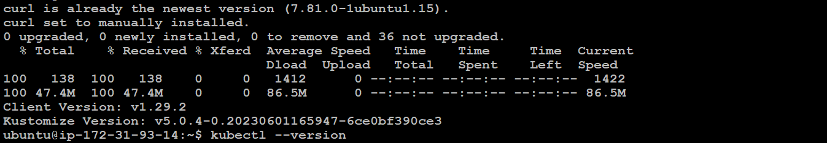

B. Now we are setting up 2 instances: Master and slave nodes for kubernetes:

Number of instances:2

Name: kubernetes

select required key pair sg and dflt volume

launch these instances:

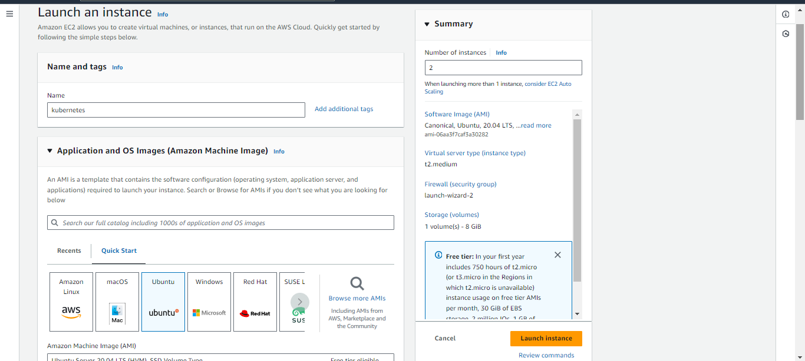

Image: ubuntu

Version: 20.04 lts not with sql server.

select required key pair sg and dflt volume

launch these instances:

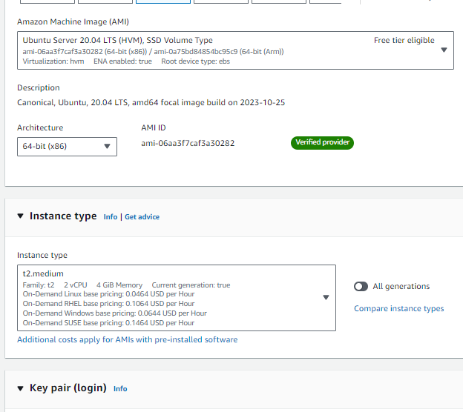

select required key pair sg and dflt volume

launch these instances:

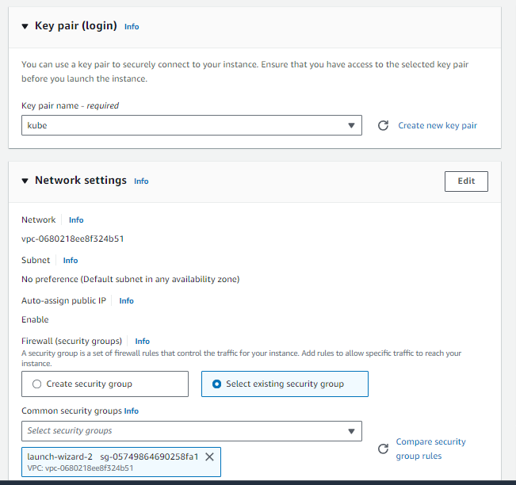

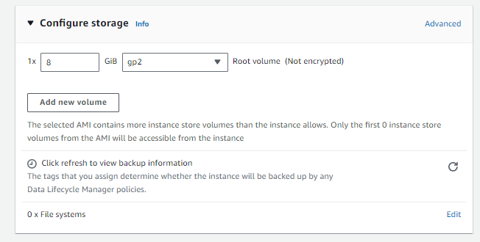



C. Conect both instances:

Do these respectively:

* sudo hostnamectl set-hostname K8s-Master
* exec bash
* sudo hostnamectl set-hostname K8s-Worker
* exec bash

**D. Run these cmd on both master and worker node:**

* sudo apt-get update -y
* sudo apt-get install -y docker.io
* sudo usermod –aG docker Ubuntu
* newgrp docker
* sudo chmod 777 /var/run/docker.sock
* sudo curl -s <https://packages.cloud.google.com/apt/doc/apt-key.gpg> | sudo apt-key add -
* sudo tee /etc/apt/sources.list.d/kubernetes.list <<EOF
* deb <https://apt.kubernetes.io/> kubernetes-xenial main
* EOF
* sudo apt-get update
* sudo apt-get install -y kubelet kubeadm kubectl
* sudo snap install kube-apiserver

E. ----------- Master only---------------

* sudo kubeadm init --pod-network-cidr=10.244.0.0/16
* copy above kube discovery key and run after these listed steps are completed.
* # in case your in root exit from it and run below commands
* mkdir -p $HOME/.kube
* sudo cp -i /etc/kubernetes/admin.conf $HOME/.kube/config
* sudo chown $(id -u):$(id -g) $HOME/.kube/config
* kubectl apply -f <https://raw.githubusercontent.com/coreos/flannel/master/Documentation/kube-flannel.yml>

F.------Worker Node------

* sudo kubeadm join <master-node-ip>:<master-node-port> --token <token> --discovery-token-ca-cert-hash <hash>

E.---------Master Node-----------

* kubectl get nodes
* cat .kube/config ------ copy the contents of these files and save it some where safe.
* 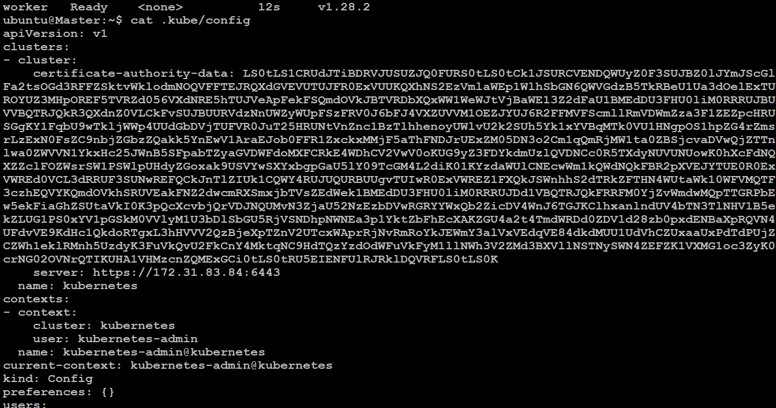

F. Install kubernetes plugins on jenkins server and gui level of jenkins:

* Kubernetes Client API
* Kubernetes Credentials
* Kubernetes
* Kubernetes CLIVersion
* Kubernetes Credentials Provider

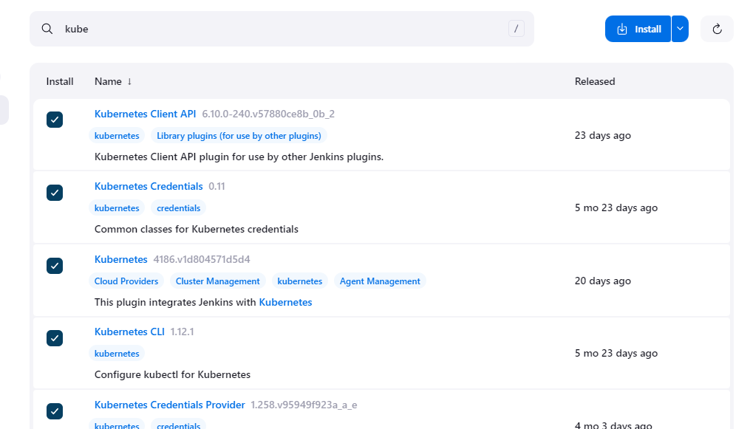

G. Goto manage Jenkins --> manage credentials --> Click on Jenkins global --> add credentials.

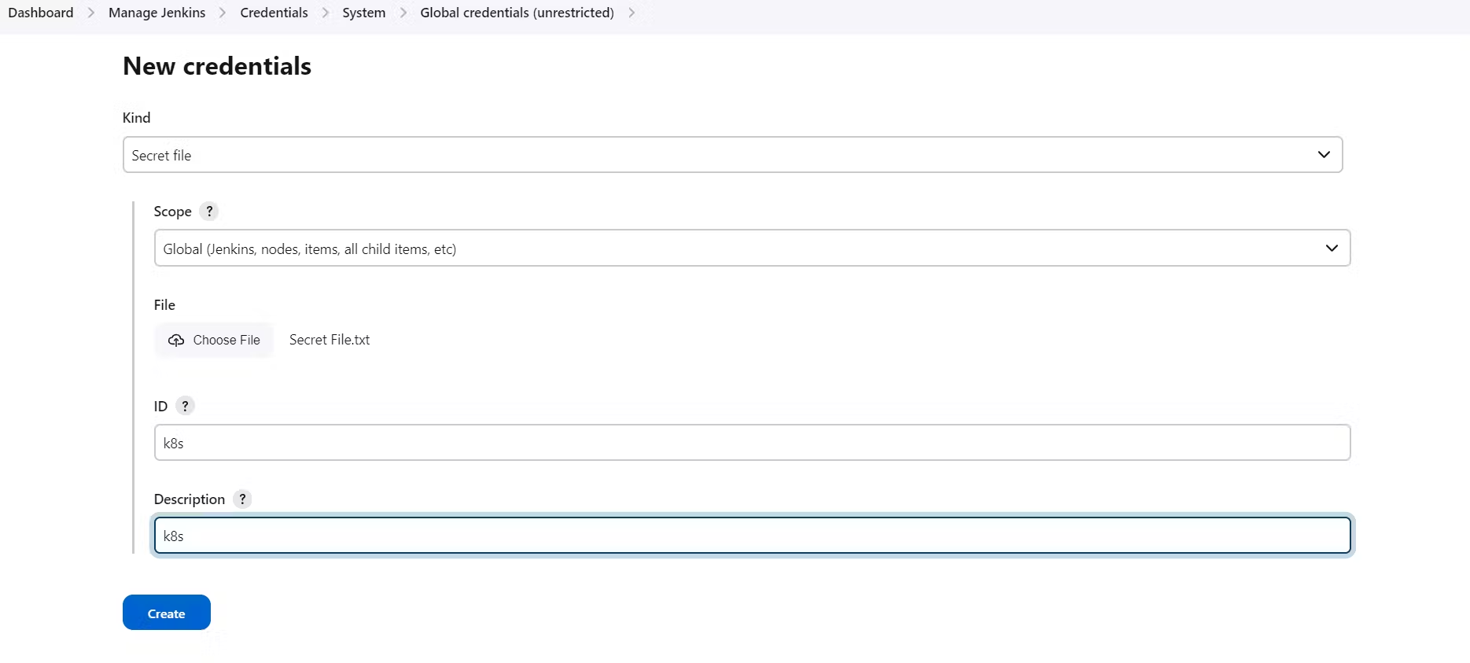

H. Install Node_exporter on both master and worker.

Let's add Node_exporter on Master and Worker to monitor the metrics. First, let's create a system user for Node Exporter by running the following command:

sudo useradd \

--system \

--no-create-home \

--shell /bin/false node_exporter

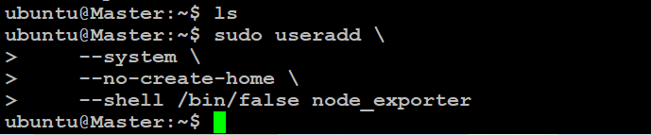

I. download Node Exporter on both master and worker node:

* wget <https://github.com/prometheus/node_exporter/releases/download/v1.6.1/node_exporter-1.6.1.linux-amd64.tar.gz>
* tar -xvf node_exporter-1.6.1.linux-amd64.tar.gz
* Now copy entire 3 lines together and run on both nodes:-

sudo mv \

node_exporter-1.6.1.linux-amd64/node_exporter \

/usr/local/bin/

* rm -rf node_exporter*
* node_exporter --version
* node_exporter --help
* sudo vim /etc/systemd/system/node_exporter.service

#Insert this in the empty file on both nodes:

[Unit]

Description=Node Exporter

Wants=network-online.target

After=network-online.target

StartLimitIntervalSec=500

StartLimitBurst=5

[Service]

User=node_exporter

Group=node_exporter

Type=simple

Restart=on-failure

RestartSec=5s

ExecStart=/usr/local/bin/node_exporter \

--collector.logind

[Install]

WantedBy=multi-user.target

* ESC+ :wq!
* sudo systemctl enable node_exporter
* sudo systemctl start node_exporter
* sudo systemctl status node_exporter
* 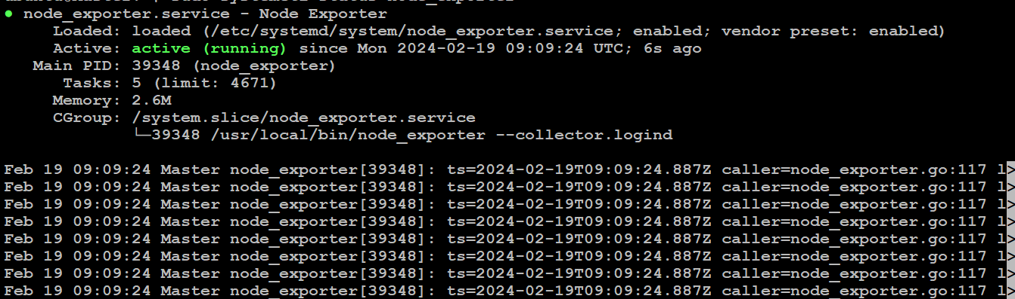
* If errors are there run this cmd:
* journalctl -u node_exporter -f --no-pager

K. Go to prometheus instance and run this md:

* sudo vim /etc/prometheus/prometheus.yml

- job_name: node_export_masterk8s

static_configs:

- targets: ["<master-ip>:9100"]

- job_name: node_export_workerk8s

static_configs:

- targets: ["<worker-ip>:9100"]

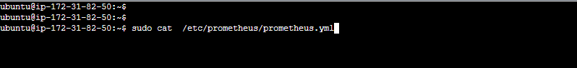

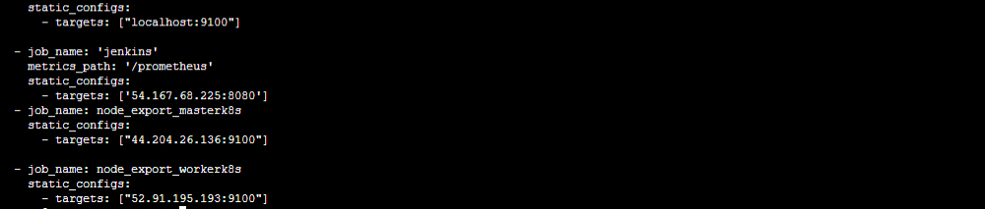

* Check the config:
* promtool check config /etc/prometheus/prometheus.yml
* 

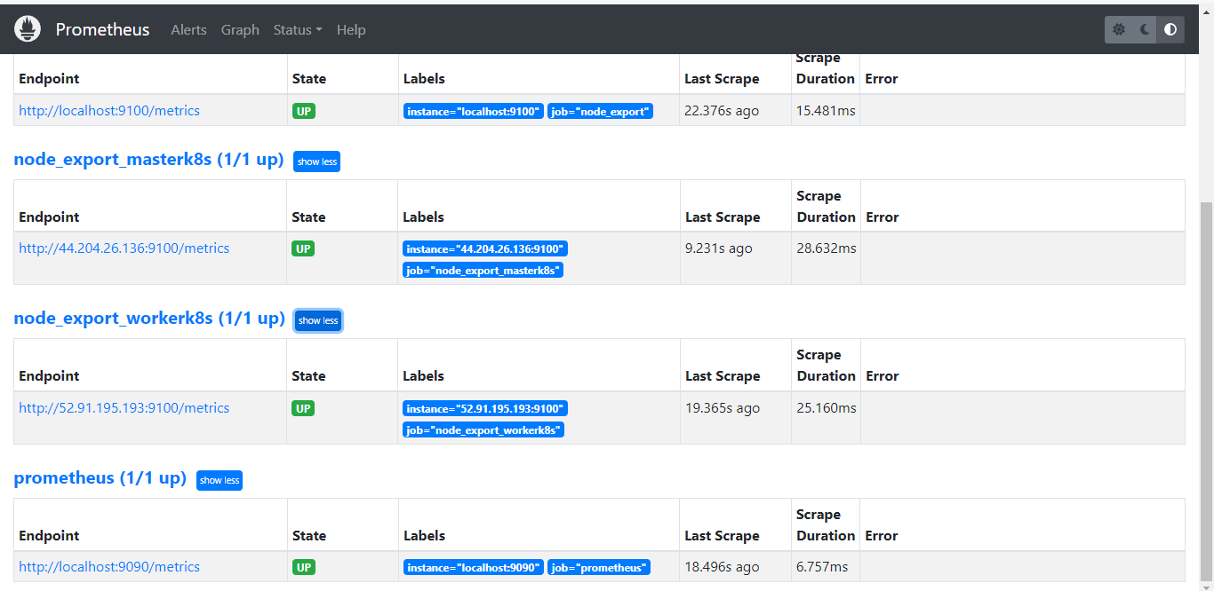

**Step 19: Deploy to kubernetes:**

A. Add this in your pipeline config:

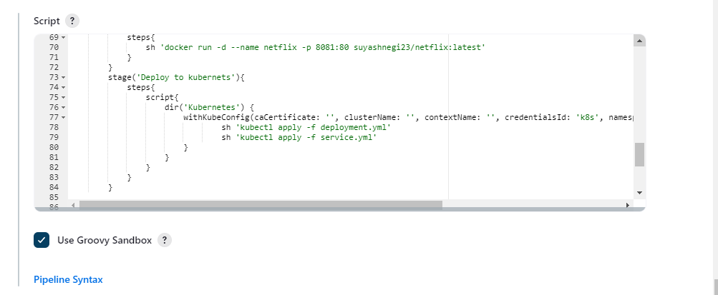

Apply and save.

stage('Deploy to kubernets'){

steps{

script{

dir('Kubernetes') {

withKubeConfig(caCertificate: '', clusterName: '', contextName: '', credentialsId: 'k8s', namespace: '', restrictKubeConfigAccess: false, serverUrl: '') {

sh 'kubectl apply -f deployment.yml'

sh 'kubectl apply -f service.yml'

}

}

}

}

}

Apply and save then build

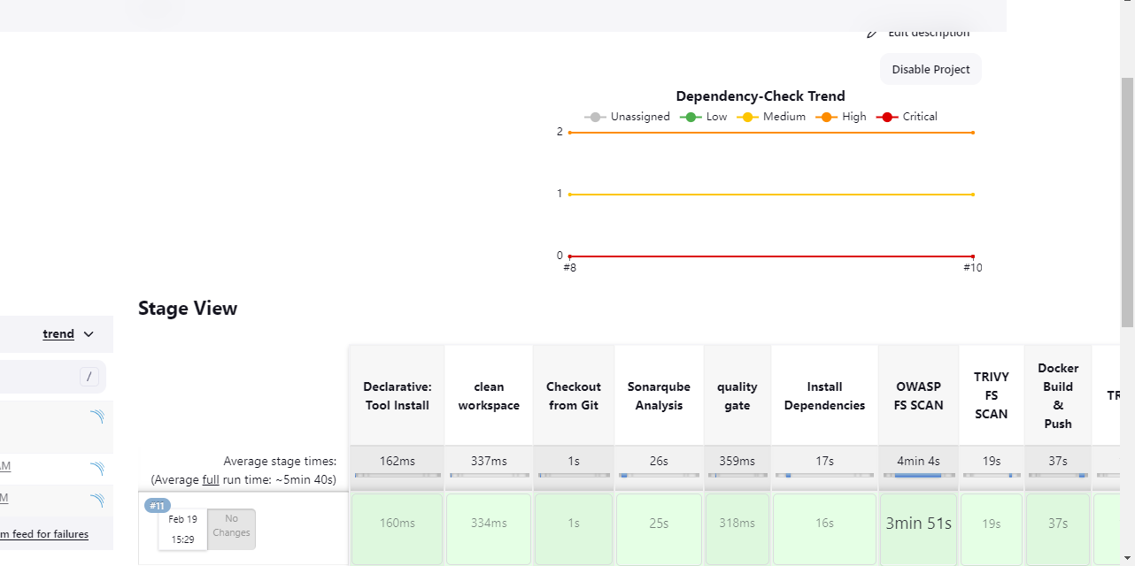



Final pieline:

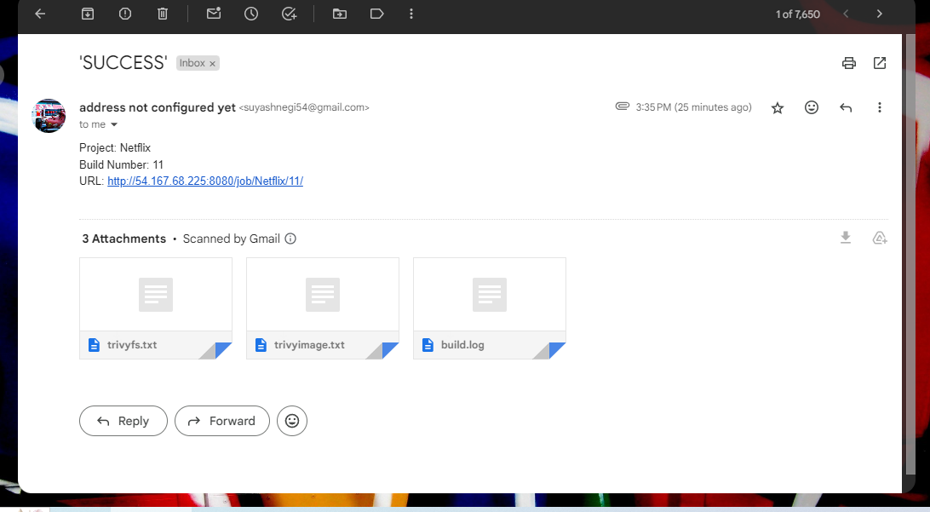

pipeline{

agent any

tools{

jdk 'jdk17'

nodejs 'node16'

}

environment {

SCANNER_HOME=tool 'sonar-scanner'

}

stages {

stage('clean workspace'){

steps{

cleanWs()

}

}

stage('Checkout from Git'){

steps{

git branch: 'main', url: '<https://github.com/Aj7Ay/Netflix-clone.git>'

}

}

stage("Sonarqube Analysis "){

steps{

withSonarQubeEnv('sonar-server') {

sh ''' $SCANNER_HOME/bin/sonar-scanner -Dsonar.projectName=Netflix \

-Dsonar.projectKey=Netflix '''

}

}

}

stage("quality gate"){

steps {

script {

waitForQualityGate abortPipeline: false, credentialsId: 'Sonar-token'

}

}

}

stage('Install Dependencies') {

steps {

sh "npm install"

}

}

stage('OWASP FS SCAN') {

steps {

dependencyCheck additionalArguments: '--scan ./ --disableYarnAudit --disableNodeAudit', odcInstallation: 'DP-Check'

dependencyCheckPublisher pattern: '**/dependency-check-report.xml'

}

}

stage('TRIVY FS SCAN') {

steps {

sh "trivy fs . > trivyfs.txt"

}

}

stage("Docker Build & Push"){

steps{

script{

withDockerRegistry(credentialsId: 'docker', toolName: 'docker'){

sh "docker build --build-arg TMDB_V3_API_KEY=01ea2f5bb67edd22e680cc175a061f82 -t netflix ."

sh "docker tag netflix suyashnegi23/netflix:latest "

sh "docker push suyashnegi23/netflix:latest "

}

}

}

}

stage("TRIVY"){

steps{

sh "trivy image suyashnegi23/netflix:latest > trivyimage.txt"

}

}

stage('Deploy to container'){

steps{

sh 'docker run -d --name netflix -p 8081:80 suyashnegi23/netflix:latest'

}

}

stage('Deploy to kubernets'){

steps{

script{

dir('Kubernetes') {

withKubeConfig(caCertificate: '', clusterName: '', contextName: '', credentialsId: 'K8s', namespace: '', restrictKubeConfigAccess: false, serverUrl: '') {

sh 'kubectl apply -f deployment.yml'

sh 'kubectl apply -f service.yml'

}

}

}

}

}

}

post {

always {

emailext attachLog: true,

subject: "'${currentBuild.result}'",

body: "Project: ${env.JOB_NAME}<br/>" +

"Build Number: ${env.BUILD_NUMBER}<br/>" +

"URL: ${env.BUILD_URL}<br/>",

to: 'suyashnegi54@gmail.com',

attachmentsPattern: 'trivyfs.txt,trivyimage.txt'

}

}

}

========================================================================

**The end**